Master’s Thesis
Liebherr Draglines in Mining Operations in India – Technical Feasibility and Economic Evaluation

Subtitle of the paper (optional)

Ajay Bihari Sahu

Declaration of Authorship

„I declare in lieu of oath that this thesis is entirely my own work except where otherwise indicated. The presence of quoted or paraphrased material has been clearly signaled and all sources have been referred. The thesis has not been submitted for a degree at any other institution and has not been published yet.”

Preface, Dedication, Acknowledgement

Abstract

Zusammenfassung

Table of Contents

Declaration of Authorship II
Preface, Dedication, Acknowledgement III
Abstract IV
Zusammenfassung V
Table of Contents VI
1 Introduction 1
1.1 Indian surface mining and overburden removal 1
1.2 Problem statement and motivation 2
1.3 Objectives of the Study 3
1.4 Scope and Limitations 3
1.5 Methodology and Outlines 5
1.6 Thesis Structure 6
2 Background and Literature Review 7
2.1 Economic and Regulatory Context 9
2.2 Geological and Mineral Resource Setting 10
2.3 Production trends 12
2.4 Dragline Mining in India-History and Deployment 14
2.5 Outlook to 2030 and Beyond 16
2.6 Liebherr Dragline – Applicability to Indian Operations 19
3 Dragline selection and Influencing Parameter 22
3.1 Selection of Overburden removal Equipment 23
3.1.1 Dragline Selection Criteria 25
3.1.2 Mine Geometry Criteria 25
3.1.3 Geotechnical Criteria 26
3.1.4 Importance of Fragmentation 27
3.1.5 Other Criteria 28
4 Operating Dimensions, Digging Approaches, and Spoil Management in Dragline Mining 30
4.1 Operating parameter 30
4.2 Classification 32
4.3 Cycle of Operation 33
4.4 Digging Modes 35
4.4.1 Underhand 35
4.4.2 Overhand 36
4.4.3 Spoil side & Pull back 37
4.5 Stripping Casting 38
4.5.1 Simple Side casting 38
4.5.2 Advance Bench 39
4.5.3 Extended Bench 40
4.5.4 Split Bench 41
4.5.5 Extended Key cut 42
4.6 Blasting and Fragmentation 43
4.7 Rehandling 43
4.8 Balancing Diagram 43
4.8.1 Component of Diagram 44
4.8.2 Functions of the Balancing Diagram 46
5 Production and Influencing Factor 47
5.1.1 Production formula and Factors 47
5.1.2 Production Factor Influence 47
5.1.3 Other Factor 54
5.1.4 Mining cases and Observation 54
6 Cost Modal - Total Cost of Ownership 57
6.1.1 Ownership cost 58
6.1.2 Operating cost 60
6.1.3 Indicative cost distribution 63
6.1.4 Unit cost 64
7 TCO Tool development 64
7.1 Introduction and Objective 65
7.1.1 Technical Specifications of TCO Tool 65
7.1.2 Module work flow of Dragline 66
7.2 KPI Dashboard Output 69
7.3 Verification with real data 71
7.4 Clarification on Scope 71
8 Maintenance and Case Study 72
8.1 Maintenance of Dragline 73
8.1.1 Maintenance Philosophies and Frame work 73
8.1.2 Liebherr Availability Framework 75
8.1.3 KPI Formulas 77
8.1.4 Maintenance part and Life time 78
9 Case study 82
9.1 Core data 82
9.1.1 Site and material descriptors 82
9.1.2 Site and material descriptors 83
9.2 How the data were collected (provenance & workflow) 83
9.2.1 Coal 83
9.2.2 Rock Phosphate 83
9.2.3 Limestone 84
9.2.4 Bauxite 84
9.3 Operational parameters (shift, staffing, maintenance) 84
9.4 Data table 84
9.5 Test Inputs 85
9.6 Production Result 86
9.7 Total cost 87
9.8 Cost per m3 88
9.9 Environment contribution 88
10 Result and conclusion 90
11 List of Figures 91
12 List of Tables 92
13 List of Abbreviations 93
Annex Table of Contents I
Annex II

Introduction

Mining ranks among India’s oldest and most economically significant industries. The country hosts extensive reserves of coal, iron ore, bauxite, limestone, and rock phosphate, positioning it among the world’s leading mineral producers. The sector contributes roughly 2 % of national gross value added, national energy security, and the supply of industrial raw materials.
Coal alone provides over 55 % of India’s primary energy requirement, while limestone and phosphate are indispensable for cement and fertilizer manufacturing
Surface mining accounts for the majority of India’s mineral output, particularly from large-scale mechanized operations in coal, limestone, and bauxite deposits. In the coal sector, draglines, truck–shovel fleets, and dozers constitute the principal overburden-removal systems operated by subsidiaries of Coal India Limited (CIL) and the Singareni Collieries Company Limited (SCCL). In non-coal open-pits, shovel–truck systems remain dominant; however, increasing stripping ratios, higher fuel costs, and environmental considerations have renewed interest in high-capacity, energy-efficient alternatives such as draglines.

Indian surface mining and overburden removal

Draglines represent the largest and most productive class of earth-moving machines used in surface mining. Characterized by their long boom, rope-suspended bucket, and walking mechanism, they can excavate and cast massive volumes of overburden at exceptionally low unit cost. Their introduction into Indian coalfields during the 1970s improved overburden-removal practice by enabling higher stripping ratios, minimal re-handling, and greater productivity than truck–shovel systems. Currently, draglines perform plays important role In overburden removal in major opencast coal mines (CIL and SCCL statistics 2024). The principal operational advantages are outlined below.:

- High bucket capacities (20 – 70 m³).
- Low unit operating cost due to electric drive systems,
- Minimal rehandling with direct casting of spoil,
- Long reach and depth capabilities, and
- Suitability for large-scale, continuous operations.

However, their high capital cost, complex maintenance, and limited flexibility in small or irregular deposits restrict their application. This trade-off necessitates a comprehensive technical and economic evaluation before deploying draglines in non-coal sectors such as limestone, phosphate, and bauxite mining.

Problem statement and motivation

While draglines have been successfully applied in Indian coalfields, their potential in non-coal sectors remains underexplored. Mines such as Jhamarkotra (phosphate), Dhanora (limestone), and lateritic bauxite deposits present opportunities where dragline deployment may potentially reduce costs and environmental impact.
However, the extension of dragline technology to these softer or more variable formations faces several constraints:
- Variability in bench geometries and strength (UCS ≈ 5 – 45 MPa).
- Distinct fragmentation and fill-factor behaviour in softer or moist formations
- High capital investment requirements.
- Need for reliable maintenance strategies to ensure availability.

Most mining companies continue to rely on shovel–truck systems, which entail higher operating costs, greater diesel consumption, and a larger carbon footprint. The absence of systematic, data-driven evaluation frameworks restricts informed decision-making on the technical and economic suitability of draglines in other mineral sectors.

Objectives of the Study

The present study aims to evaluate the potential technical and economic feasibility of deploying Liebherr’s HS 8300-class and forthcoming LMD 3000 dragline in Indian surface mining operations, with a focus on phosphate, limestone, and bauxite mines. The specific objectives are:
- To review the principles of dragline operation, productivity models, and influencing factors.
- To analyze bench geometry and overburden characteristics of selected Indian deposits.
- To develop a Total Cost of Ownership (TCO) framework for draglines, integrating ownership, operating, and maintenance costs and strategy.
- To compare dragline economics under Indian conditions.
- To evaluate the technical and environmental implications and to outline validation requirements for future field assessment.

Scope and Limitations

The scope of this research is limited to large-scale surface mining operations in India where dragline deployment is technically feasible. The study focuses on:
- Commodities: coal, phosphate, limestone, and bauxite.
- Mining methods: side-cast, extended bench, and rehandling scenarios.
- Equipment: Liebherr HS 8300-class dragline as the reference machine.
- Geographic scope: case studies from Indian mines (e.g., Jhamarkotra, Dhanora, SCCL coalfields).
- Modal and Analysis tools: OEM productivity data, CMPDI cost norms, and literature (SME, USBM CES Handbook)

Limitations include:
  - Data availability: Comprehensive field data are limited, particularly for non-coal mines where draglines have not yet been deployed.
  - Cost estimation: Certain parameters draw on secondary technical sources such as the U.S. Bureau of Mines Cost Estimation System (CES) Handbook and the SME Mining Engineering Handbook, subsequently escalated to current Indian price levels using producer-price indices and exchange rates.
  - Model assumptions: The TCO framework adopts standard availability and utilization benchmarks in accordance with CMPDI and CIL operational norms. Adjustments for site-specific operating conditions were evaluated using Liebherr field performance data and guidance from the SME Mining Engineering Handbook.

Methodology and Outlines

The research methodology integrates literature synthesis, case-study evaluation, and quantitative cost-modeling to assess the technical and economic feasibility of dragline deployment in Indian surface-mining conditions. The workflow comprises the following sequential steps:

  - Data acquisition: Collection and verification of geological, geotechnical, operational, and economic parameters from representative Indian coal and non-coal mines through published reports, corporate records, and site documentation.
  - Productivity modeling: Application of dragline production equations based on cycle-time components, swing-angle geometry, fill factors, and availability/utilization ratios to estimate hourly and annual output.
  - Economic modeling (TCO): Development of a Total Cost of Ownership framework encompassing CAPEX, OPEX, maintenance, and salvage elements; conversion to unit cost (₹/m3 and ₹/ton) .
  - Maintenance integration: Incorporation of inspection- and reliability-based maintenance (RBM/CBM) strategies derived from OEM and Liebherr standards to evaluate downtime effects on availability.
  - Environmental evaluation: Quantification of carbon-emission contributions using diesel-consumption and electricity-emission factors (2.68 kg CO₂ per L diesel, 0.82 kg CO₂/kWh grid average 2024)

This mixed-method approach triangulation between technical, economic, and environmental dimensions, supporting reproducible, evidence-based conclusions

Thesis Structure

The thesis is organized into the following chapters:

Chapter | Title | Core Content
1 | Introduction | Context, gap, objectives, methodology.
2 | Background & Literature Review | Indian mining economy, dragline evolution, global studies.
3 | Dragline Selection Parameters | Geotechnical and geometric criteria.
4 | Operating Dimensions & Balancing | Cycle mechanics and spoil management.
5 | Productivity & Influencing Factors | Empirical models, validation.
6 | TCO Framework | Life-cycle cost equations.
7 | Tool Development | Web-based TCO-ESG dashboard.
8 | Maintenance & Availability | Reliability and CBM framework.
9 | Case Study – India | Model application and validation.
10–12 | Results, Conclusions, References | Findings and future outlook.

Background and Literature Review

The first commercial dragline was designed by John W. Page in 1904 for the Chicago Canal project, introducing the rope-suspended bucket concept later refined by Page Engineering through arched and archless bucket designs. Bucyrus entered the market in 1910 after acquiring rights to the Heyworth–Newman excavator, launching the Class 14 crawler dragline in 1911 and pioneering electric power for large stripping shovels by 1912. P&H (Harnischfeger Corporation) developed early gasoline-powered models in 1914 and later acquired Page in 1988, while Marion Power Shovel built its first walking dragline in 1939, culminating in the Marion 6360 with a ≈138 m³ bucket. Bucyrus acquired Marion in 1997, consolidating major U.S. dragline technology. In parallel, the Soviet Union’s Uralmash and other manufacturers developed long-boom walking draglines (up to 120 m) for spoil re-handling and dredging applications..

Parker bay 2023 data base

Globally, nearly 70 % of draglines operate in coal mines, while the remainder serve soft-rock deposits such as phosphate (9 %), limestone (1.5 %), and bauxite (1.9 %) (Parker Bay Database, 2023). In India, draglines are likewise concentrated in the coal sector; however, the country holds significant reserves of limestone (5th largest), bauxite (5th), and phosphate (13th)—minerals that share similar geotechnical and geometric characteristics with coal overburden.

Hybrid duty-cycle machines such as the Liebherr HS 8300 and HS 8300 E integrate diesel or electric drives with the Pactronic® hydraulic-energy-recovery system, reported by Liebherr it reduce fuel consumption by approximately 15- 25% and CO2 emissions 20-30% in harbour operation
The crawler-mounted design allows multi-pit relocation, bridging the gap between large walking draglines and hydraulic excavators.Power demand is 240–320 kWh (electric version) or 750 kW diesel, bucket ≈ 11 m³, boom ≤ 50 m.
This scale is ideal for phosphate and limestone deposits with moderate stripping ratios (< 1:4).International benchmarks (e.g., Florida phosphate, European limestone) report unit costs 30–40 % below truck–shovel when geometry permits.

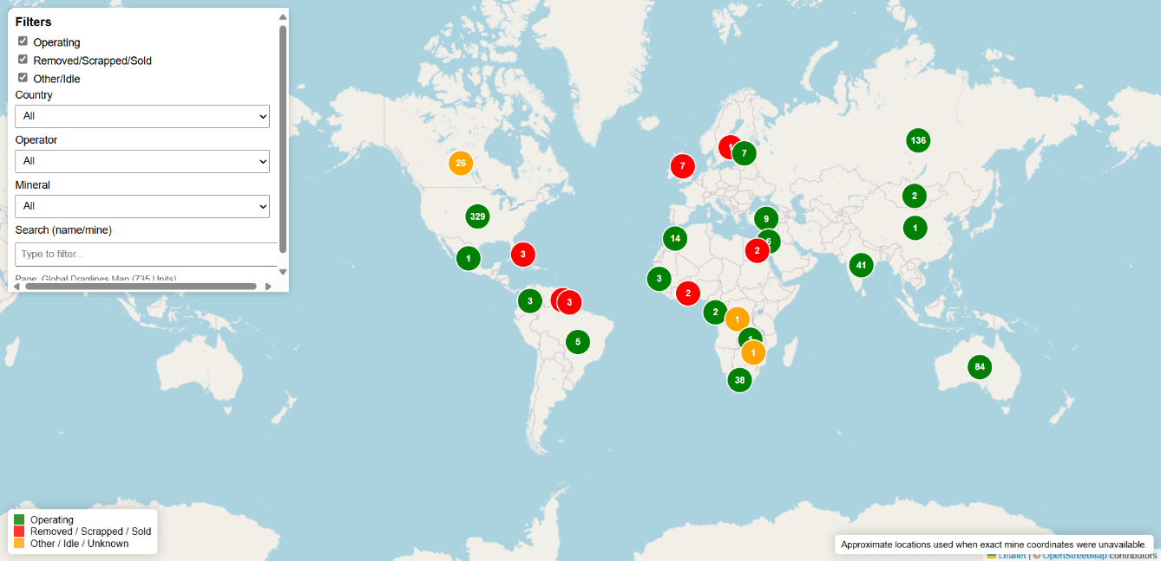

Source – Parker bay 2023

The global dragline distribution (Figure 2-1) shows that the U.S., Russia, and Australia collectively operate over 70 % of the world’s active draglines, highlighting their dominance in large-scale ore and overburden removal.
India ranks fourth, reflecting a mature but relatively smaller fleet focused primarily on Coal India Limited and Singareni operations.

Economic and Regulatory Context

Mining and quarrying underpin India’s industrial economy by supplying essential inputs for power generation, steel, cement, and fertilizers. In FY 2023–24, the sector contributed about 2.21% of Gross Value Added (GVA)—a modest share in a services-led economy, yet critical for downstream industries.
The legal framework classifies minerals into:
- Fuel minerals (coal, lignite, oil, gas) under the Ministries of Coal and Petroleum;
- Major minerals (non-fuel, non-atomic) regulated by the Indian Bureau of Mines (IBM) under the MMDR Act and MCDR 2017;
- Atomic minerals (e.g., uranium, thorium) under the Department of Atomic Energy;
- Minor minerals (building stone, sand, clay, etc.) administered by state governments;
- Offshore minerals under a separate offshore regime.

This thesis focuses on large-scale open-cast extraction of fuel and selected major minerals—primarily coal and phosphate—which fall under central oversight. Minor and offshore minerals are excluded, as are contexts where draglines are impractical.

Open-cast mining has a significant spatial footprint. As of March 2023, 3,000+ active leases for major minerals covered 2,824 km². Operations cluster in mineral belts such as the central–eastern coalfields and Rajasthan’s phosphate terrain. The predominance of surface mining reflects shallow deposits and policy emphasis on output growth. The sections below summarize the resource base and production trends to contextualize dragline technology.

Geological and Mineral Resource Setting

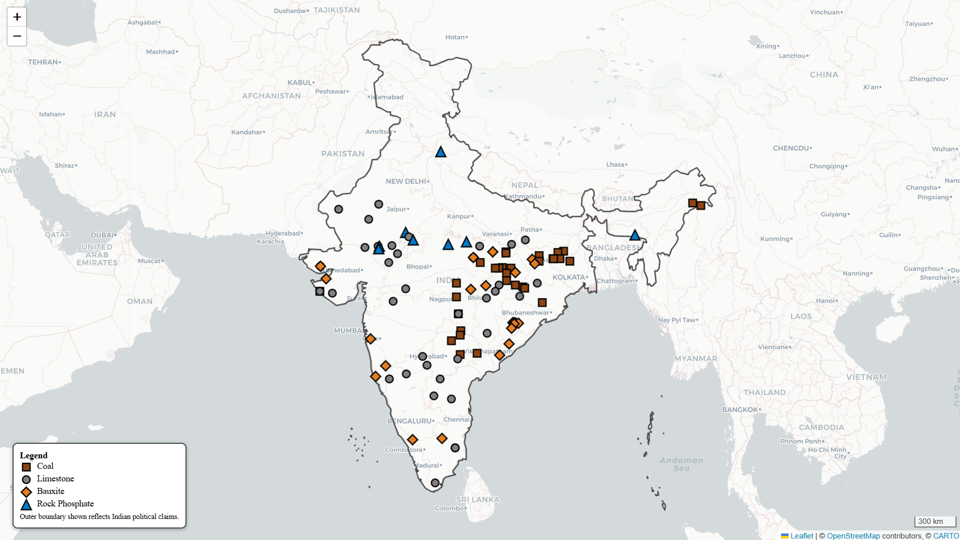

Spatial distribution of major mineral deposits in India (coal, limestone, bauxite, and rock phosphate). Link
Data sources: Indian Bureau of Mines (IBM), National Mineral Inventory Database 2023; Ministry of Mines (2023 – 24) Annual

        - Coal - Indian coal occurs chiefly in Gondwana (Permian) basins—99% of reserves—across the Damodar, Mahanadi, Son, and Wardha valleys; Tertiary coals occur in the northeast. Seam depths are largely <300 m, favoring open-cast methods. As of 1 April 2023, geological resources total 378.21 Bt (199.90 Bt measured, 151.68 Bt indicated, 25.87 Bt inferred). Coal qualities vary (high-ash bituminous to sub-bituminous/lignite), but the near-surface setting has driven an open-pit paradigm and sustained demand for efficient overburden removal systems.

        - Rock Phosphate - Indian phosphorites are chiefly Proterozoic (Aravalli Supergroup, Rajasthan). Jhamarkotra (Udaipur) is the largest deposit, with phosphorite lenses in stromatolitic dolomitic limestone mined by open pit (typical 10 m benches). Additional smaller occurrences exist in Madhya Pradesh and limited high-grade lenses in the northeast. Total resources 311 Mt, with 31 Mt proved. Ore/overburden is generally soft to moderately hard (phosphorite 30–40 MPa UCS; cherty bands 60–70 MPa occasionally need blasting). The shallow, stratified geometry is compatible with surface excavation and potentially with dragline-based stripping, as assessed later.

        - Limestone - Widespread “soft-rock” limestones occur in Proterozoic basins (e.g., Vindhyan, Cuddapah) and elsewhere. Major producing states include Rajasthan, Andhra Pradesh, Gujarat, Chhattisgarh, Madhya Pradesh. Typical bench heights are 8–15 m. Indian limestone quarries generally use shovel–truck and dozers for thin overburden; International examples (e.g., European limestone pits) indicate potential crossover where geometry and volumes suit.

        - Bauxite - Predominantly lateritic capping on plateaus (e.g., Eastern Ghats, Odisha). Typical profiles: 1–5 m laterite over 4–12 m bauxite; bench heights 6–8 m and low stripping ratios. Selective mining requirements and limited overburden volumes have favored shovel/dumper and surface miners. Draglines are generally unnecessary unless overburden thickens substantially (as seen in some international cases).

        - Other Soft -Rock Minerals Gypsum (resources around 1,330 Mt), laterite & ochre (706 Mt), and clays (few Mt/yr production) are worked by shallow open pits with conventional excavators. They demonstrate the breadth of India’s soft-rock surface mining but fall outside the primary focus unless scale and geometry justify high-capacity stripping.

Production trends

India ranks among the world’s leading producers of several bulk and industrial minerals, with production volumes dominated by coal and limestone. Most mining operations are open-cast, reflecting favourable geology, lower stripping costs, and long-established surface-mining infrastructure. The following table summarises the current scale of India’s major mineral resources, reserves, and production (FY 2024–25 provisional), together with global rankings and resource-to-production ratio

Major Mineral Reserves and Production (2024)
Commodity | Resources  (Mt) | Reserves (Mt) | Production (2024 -25Mt) | Resource production ratio | World Rank (Prod.)
Coal | 378210 | 361410 | 1 047.7 | 361 years | 2
Rock Phosphate (P₂O₅) | 311.25 | 31 | 1.6-1.8 | 170-190 years | 16–17
Limestone | 227589 | 19028 | 450 | 505 years | 2
Bauxite | 4958 | 650 | 25 | 200 years | 5

Sources: USGS MCS 2025 (Bauxite, Phosphate Rock, Lime); IBM (2022) Limestone & Dolomite; MoC (2024) Coal Report; CMA (2024) Cement Industry Limestone and Future Outlook

Coal:
FY 2023–24 production: 997.23 Mt, of which 962.52 Mt open-cast and 34.71 Mt underground 2024–25 (provisional): 1,047.7 Mt.
Open-cast accounts for >95% of output; underground 4%, constrained by cost, geology, and safety.
Stripping ratios range widely (up to 1:5 bcm/t in some pits), implying tens of Mbcm of overburden annually—making efficient stripping central to mine economics.

Rock Phosphate:
1.6 Mt in 2024–25, >90% from Rajasthan; domestic supply covers 13% of demand (import-dependent).
Limestone:
450 Mt in 2024–25; resources 227.59 Bt; contributes 91.2% of non-metallic mineral value; growth 4–5% CAGR (cement demand).
Bauxite:
25 Mt in 2024–25; resources 4,958 Mt; Odisha hosts 59% of reserves.

Minor minerals (sand, gravel, building stone) contribute very large aggregate tonnages via numerous small pits under state regulation—these typically use conventional excavators and trucks rather than draglines. Atomic minerals are niche and outside scope.

Dragline Mining in India-History and Deployment

Draglines—rope-suspended bucket excavators equipped with long lattice booms and typically mounted on walking bases—became integral to India’s large-scale open-cast coal operations from the early 1970s onward. Initially imported from the USSR, the United States, and the United Kingdom, and later domestically produced by Heavy Engineering Corporation (HEC), these machines enabled high-throughput overburden stripping by direct casting of spoil into adjacent voids, thereby eliminating truck haulage for waste removal and reducing operational costs.
During the 1980s and 1990s, the deployment of draglines expanded rapidly across subsidiaries of Coal India Limited (CIL) and the Singareni Collieries Company Limited (SCCL), marking a transition toward high-capacity, continuous excavation systems. Although fleet growth has plateaued in recent years, draglines continue to form the backbone of India’s overburden-removal capacity in several major opencast coal projects.
SR NO | Company | Mine | OEM (at build) | Model | Bucket (m³) | Boom (m) | Qty
1 | ECL | Sonepur Bazari | Marion CAT | 7820 | 26,8 | 88 | 1
2 | SECL | Bisrampur | Marion CAT | 7800 | 30 | 70 | 1
3 | NCL | Jayant | Ransomes & Rapier CAT | W2000 | 24 | 96 | 3
4 | NCL | Jayant | Uralmash | ESH15/90 | 15 | 90 | 1
5 | NCL | Jayant | Uralmash | ESH24/95 | 24 | 95 | 2
6 | NCL | Amlohri | HEC | 24/88 | 24 | 88 | 3
7 | NCL | Amlohri | Ransomes & Rapier CAT | W2000 | 24 | 96 | 1
8 | NCL | Dudhichua | Ransomes & Rapier CAT | W2000 | 24 | 96 | 3
9 | NCL | Dudhichua | Bucyrus CAT | W2000 | 24 | 96 | 1
10 | NCL | Nigahi | Bucyrus CAT | W2000 | 24 | 96 | 2
11 | NCL | Nigahi | Uralmash | ESH20/90 | 20 | 90 | 2
12 | NCL | Bina | Ransomes & Rapier CAT | W2000 | 24 | 96 | 2
13 | NCL | Bina | Uralmash | ESH24/95 | 24 | 95 | 1
15 | NCL | Khadia | Uralmash | ESH20/90 | 20 | 90 | 2
16 | BCCL | Jharia Block II | Ransomes & Rapier CAT | W2000 | 24 | 96 | 1
17 | Reliance Power | Sasan | Bucyrus CAT | 8200 | 40 | 98 | 2
18 | Singareni | Ramagundam OC#3 | Marion CAT | 7820 | 30 | 70 | 1
 |  |  |  | Total |  |  | 29

Source – Parker bay database 2023 and refined by CIL annual report 2025

As of March 2023, according to Parker Bay Database (2023) and CIL Annual Reports (2025), approximately 29 draglines were operational in Indian coalfields. Their bucket capacities range from 5 to 40 m³, with boom lengths between 70 and 100 m, spanning models from legacy Uralmash, Bucyrus, Marion, and Ransomes & Rapier designs to indigenous HEC units. Under favorable site and material conditions, individual machines can achieve annual overburden movement rates exceeding 3–4 million bcm.

Source -Parker bay and CIL

The primary advantages driving their continued use are their low unit stripping cost at moderate swing angles, minimal rehandling, and energy-efficient direct casting. When the pit geometry allows for side casting, a single dragline can effectively replace large truck–shovel fleets, thereby reducing diesel consumption, traffic congestion, and maintenance overheads..
Despite their proven productivity and reliability, the Indian dragline sector faces several persistent challenges:
- High Capital Intensity: Procurement and assembly costs remain substantial, with long commissioning lead times and specialized infrastructure requirements.
- Limited Mobility: Walking mechanisms restrict relocation flexibility between pits or benches.
- Operational Sensitivity: Productivity is highly dependent on consistent floor stability, controlled blast fragmentation, and favorable pit geometry.
- Aging Fleet: A significant proportion of units are over 25 years old, leading to rising maintenance costs and lower mechanical availability.

These constraints have prompted initiatives toward fleet modernization, refurbishment programs, and exploration of alternative configurations—including crawler-mounted duty-cycle draglines such as the Liebherr HS 8300 series And LMD 3000 —for medium-large scale deposits where full-size walking machines are not economically or logistically justified.

Outlook to 2030 and Beyond

Coal
Despite India’s climate pledges (net zero by 2070), coal will remain the backbone of power generation until at least 2040. NITI Aayog projects production rising to 1.3–1.5 Bt by 2030, mostly from opencast mines.
Draglines will remain core to high-volume OB stripping: Coal India has continued procuring large walking draglines, including a 2021 award for five ESH 24/95 units (Uralmashplant) and recent commissioning at NCL Bina (“Swarna” dragline), reinforcing the method’s role in bulk, low-cost overburden removal.
Liebherr units have been reported as effective in international topsoil removal in German coal mine
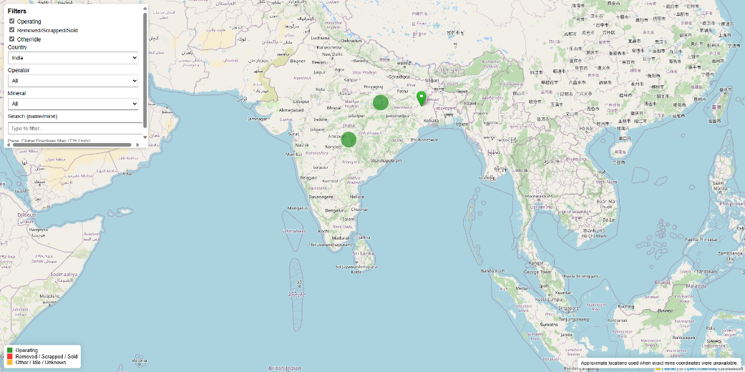
Dragline In coal india
Phosphate
Targeted beneficiation projects in Rajasthan and exploration in Madhya Pradesh and Meghalaya may increase domestic supply. There may be scope to adopt mobile duty-cycle draglines—e.g., Liebherr HS 8300—for soft-rock strip/trench work in select rock-phosphate orebodies (Rajasthan/MP): These units have been reported as effective in international applications .Currently no dragline is used in phosphate mining in India
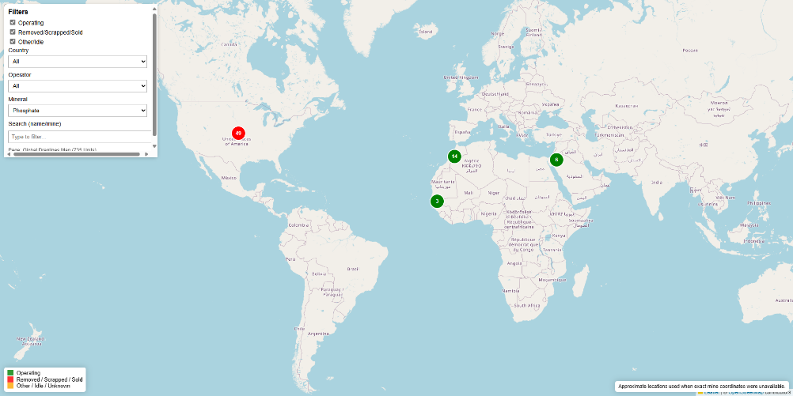
Dragline use in Phosphate based on parker bay

Limestone and bauxite
Projected growth of the cement industry (5–6 % p.a.) will increase demand for limestone extraction. Bauxite mining in Odisha and Andhra Pradesh continues under lateritic conditions with relatively thin overburden.
While both sectors rely mainly on shovel–truck and surface-miner systems, long-reach duty-cycle draglines may offer advantages in specific cases—particularly wet pits or below-water-table operations—by reducing haulage and improving energy efficiency.
Liebherr Dragline have been reported as effective in production in international Limestone mining in Europe and bauxite in Brazil.
Currently, no draglines are employed in Indian limestone or bauxite mining , though selective trials could demonstrate economic viability under suitable geometries.
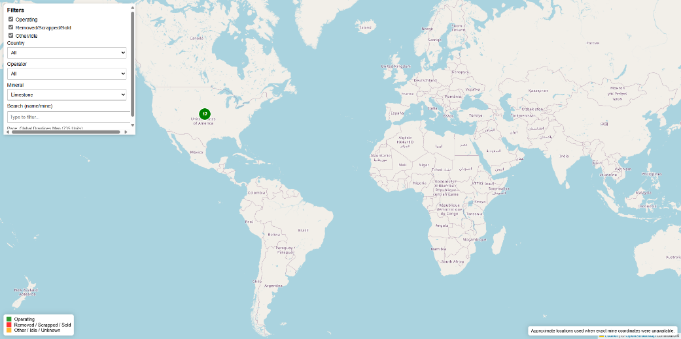
Dragline use in Limestone based on parker bay
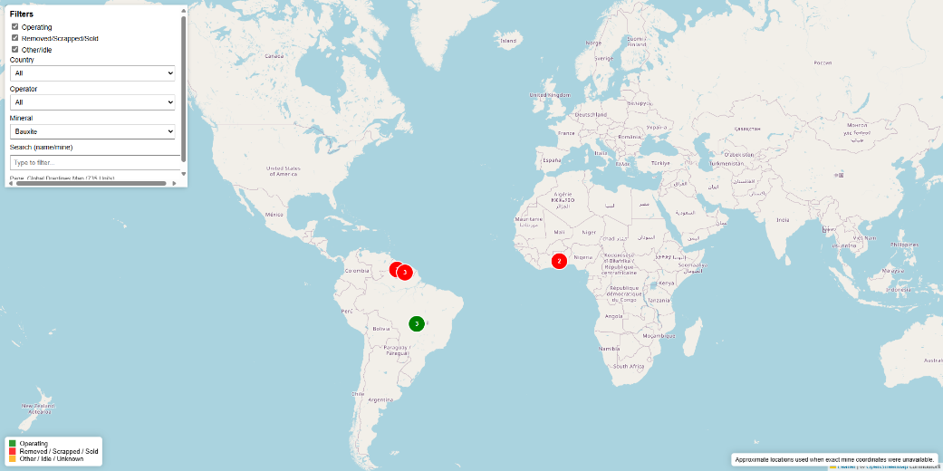
Dragline use in Bauxite based on parker bay

Given India’s soft-rock portfolios, mobile duty-cycle draglines such as Liebherr’s HS 8300 present a high-potential pathway to raise productivity and lower CO₂ intensity by curbing diesel haulage—backed by hybrid energy recovery and even all-electric (induction) drive where power is available.

Liebherr Dragline – Applicability to Indian Operations

India’s current draglines are largely walking machines. The Liebherr HS series represents a crawler-mounted, duty-cycle platform configurable as a crawler dragline, offering greater mobility for short relocations and multi-use duty (drag, clamshell, etc.).
This places the HS 8300 ( often designated HS 8300 HD or HS 8300.2 in its updated form) below India’s largest walking units but above typical hydraulic excavators, creating a mid-scale stripping niche. Its mobility suits bench-by-bench advance, pit-level relocations, and sites where a full-size walking dragline is unjustified.
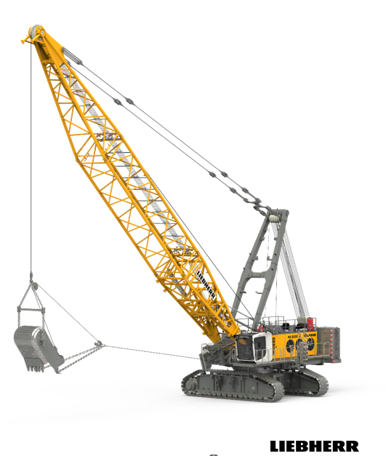
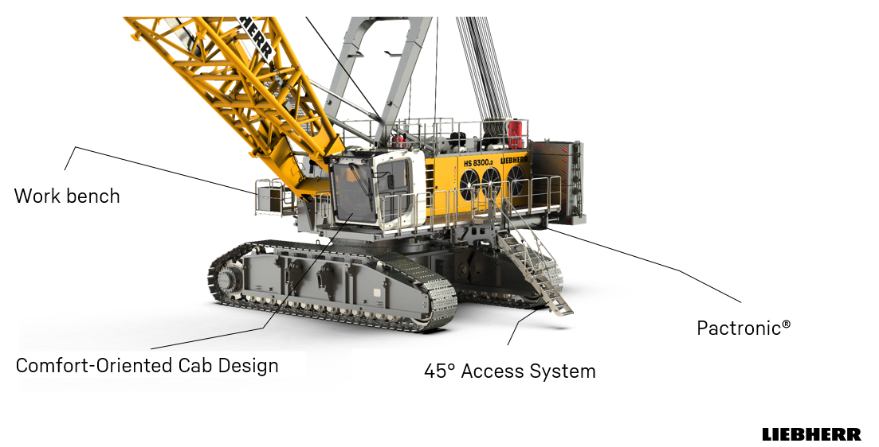

Liebherr HS 8300

Aspect | HS 8300 ( Diesel / Hybrid ) | HS 8300 E ( Electric )
Machine Type | Crawler-mounted duty-cycle crane configurable as dragline, clamshell, or grab unit | Same base unit, fully electric drive
Operating Weight / Class | ≈ 300 t | ≈ 350 t
Drive System | Diesel engine ( 750 kW ) +Pactronic® hybrid | ABB three–phase a.c. Motor –  2 x 345kW  Pactronic® hybrid
Energy Consumption | ≈ 70–80 L diesel/h ( hybrid-assisted ) | ≈ 240–320 kWh/h
Boom Length (max) | Up to 50 m | Up to 50 m
Bucket Capacity (dragline mode) | 11 – 13 m³ | Up to 11 m³
Mobility / Travel | Crawler undercarriage (~ 1.4 km/h) | Crawler undercarriage

In phosphate settings like Jhamarkotra—10 m benches, soft to moderately hard strata—the HS 8300 could strip overburden (and potentially dig ore) with limited pre-blast in harder bands. In coal/lignite or pre-stripping roles, it can remove topsoil/alluvium or operate as a flexible high-capacity unit where electrical infrastructure for walking draglines is absent.

Liebherr Pactronic® Hybrid Drive System

The Pactronic® hybrid drive is Liebherr’s patented hydraulic-energy recovery system, designed to enhance the performance of duty-cycle cranes such as the HS 8300 series. The system integrates an additional hydraulic pump, motor, and a nitrogen-charged accumulator that stores surplus or regenerative energy from lowering and braking operations.

When peak power is required, the accumulator discharges through the hydraulic motor, supplementing the diesel engine. This parallel operation enables a 750 kW engine to deliver an effective system output of about 1 250 kW, increasing hoisting and lowering speeds by up to 25 % without enlarging the engine.
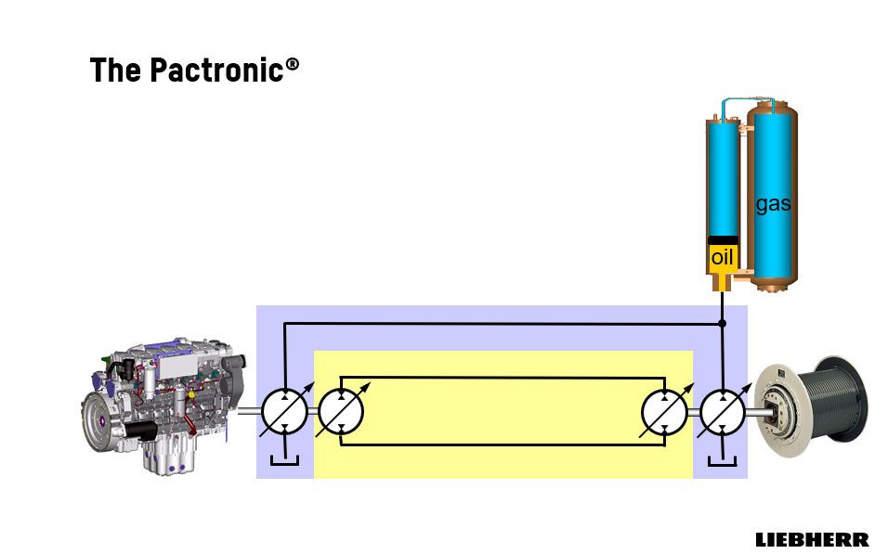
Source – Liebherr Group (2023), HS 8300 HD / E Technical Data Sheet and Hybrid Drive Brochu

The accumulator requires no cooling or conditioning, maintains constant performance across ambient temperatures, and has a service life equal to the machine. Overall, the Pactronic® system reported reduced fuel consumption around 15-25% and CO₂ emissions by roughly 20-30 %, it yields to lower maintenance costs, and combines higher productivity with improved environmental efficiency—particularly relevant for energy-intensive Indian mining operations.

Liebherr LMD Dragline Ongoing Development– Liebherr is developing the LMD-series dragline, a next-generation, fully electric mining machine positioned between duty-cycle crawlers and ultra-large walking draglines. With an operating weight of about 1250 t and a bucket capacity up to 20 m³, it targets high production with lower environmental impact.
Powered by an electric drive of roughly 1600 kW and a hybrid crawler–walking mechanism, the LMD offers improved mobility, stability, and relocation efficiency. This configuration provides walking-dragline productivity with the flexibility needed for Indian surface-mining conditions, especially where varied overburden geometry limits conventional machines.

Dragline selection and Influencing Parameter

Overburden (OB) removal constitutes the most resource-intensive component of open-cast mining, often accounting for 60–70% of the total production cost. Its efficiency directly influences mine productivity, economic viability, and environmental performance. Open-cast mining accounts for ≈ 96% of India’s coal output and virtually 100% of rock phosphate, limestone, and bauxite. Consequently, the choice of OB removal method and equipment is central to mine planning.
The stripping ratio (SR)—expressed as bank cubic metres of OB per tonne of ore/coal—is the critical design parameter governing system selection. Indicative SR ranges for major Indian commodities are:
- Coal: 1.5–4.5 bcm/t, depending on seam thickness and depth.
- Rock phosphate: 0.5–2.0 bcm/t, reflecting shallow deposits.
- Limestone: typically <1.0 bcm/t, due to thin cover.
- Bauxite: <0.5 bcm/t, with lateritic caps of 1–5 m thickness.
- Gypsum and clays: generally <0.3 bcm/t.
Source -IBM ,Moc and Indian govrt publications
These values underscore that dragline deployment is most justified in deep, bedded coal seams, whereas shallow soft-rock sectors favour smaller, flexible units

Selection of Overburden removal Equipment

Selection of an OB handling system requires a multidisciplinary assessment encompassing geological, geometric, operational, economic, and environmental factors. Comparative guidelines for typical systems are presented in the table below
Parameters | Dozer- Front-end loader | Dozer-scraper | Dragline | Excavator - truck | Excavator- mobile crusher-conveyor | Wheel excavator - conveyor
Maximum production | medium | medium | high | high | high | high
Production rate | medium | low | high | medium | medium | high
Mine life | short | short | long | medium | long | long
Mine depth | medium | flat and shallow | medium | deep | deep | medium
Deposit | Unconsolidated | Unconsolidated | Consolidated | Consolidated | Consolidated | uniform, no large boulders
Preparation | ripping | ripping | drill and blast | drill and blast | drill and blast | drill and blast
System complexity | low | medium | low | medium | high | high
Operational flexibility | high | medium | low | high | medium | low
Blending capability | high | high | low | high | medium | medium
Selective placement | good | excellent | poor | good | medium | good
Wet weather impact | high | high | low | medium | low | low
Scheduling requirements | high | low | high | high | medium | medium
System availability | medium | medium | high | medium | high | medium
Support equipment | low | medium | medium | high | high | high
Ease of start-up | simple | simple | moderate | simple | complex | complex
Investment | low | low | medium | medium | medium | high

Table 3-1 Comparison of Overburden-Removal Systems
(Adapted from Bagherpour et al., “Technical and Economic Optimisation of Surface Mining Processes,” 2007.)
The matrix highlights the low unit cost but low flexibility of draglines, the scalability of shovel–truck fleets, and the selectivity of surface miners and scrapers in thin-cover deposits.
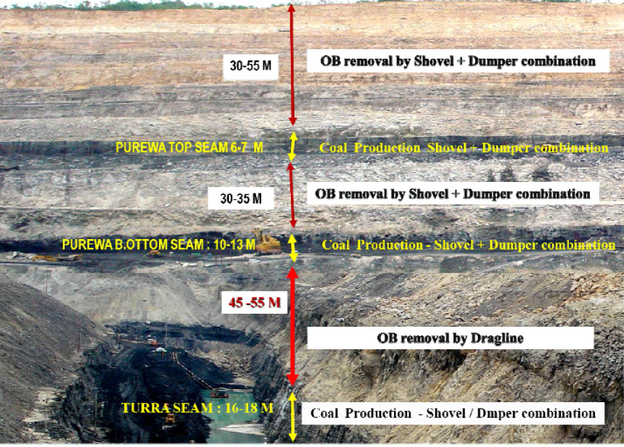

Figure 1 – A typical cross sectional view of the mine Source NCL

Equipment choice depends on stripping ratio, bench geometry, material hardness, production scale and environmental constraints. Progressive backfilling and reclamation are mandated in mine‑closure plans

Dragline Selection Criteria

Draglines represent one of the most significant technological investments in Indian opencast mining. Their adoption since the 1970s has transformed overburden removal in large coalfields, particularly in Northern Coalfields Limited (NCL) and South Eastern Coalfields Limited (SECL). Draglines are capital-intensive assets whose deployment depends on geological, geotechnical, geometric, and economic factors, supported by reliable infrastructure and regulatory compliance.

Mine Geometry Criteria

- Bench height: optimal 15–20 m for dragline benches. Where overburden exceeds effective digging depth, tandem draglines or shovel–dragline combinations are required.
- Cut width: must be adequate for dragline swing, coal shovel placement, and rehandle minimisation. Wider cuts are required in horizontal tandem operation.
- Pit depth: draglines remain effective for OB thickness up to 50–60 m; beyond this depth, multi-bench or hybrid systems are necessary.
- Strike length: longer strike lengths improve productivity by reducing machine relocations.
- Stripping ratio (SR): economic dragline operation is Economical up to 1:6 ; higher SR excessive rehandle.

Combined geometric parameters define whether a deposit supports single-bench, tandem, or hybrid (shovel–dragline) configurations.

Geotechnical Criteria

- Excavation Categories-
Draglines best suited to Cat II–III strata, Cat IV bands → require presplit or buffer blasting, Cat V → beyond dragline scope; use shovel–truck

Category | UCS (kg/cm²) | Typical material | Blasting
I | up to 55 | Alluvium, weathered OB | Nil
II | 55–125 | Soft shale/mudstone | Light
III | 125–250 | Sandstone/coal | Normal
IV | 250–1250 | Quartzite, compact sandstone | Heavy
V | >1250 | Dolerite, very hard bands | Not suitable

Table 3-2. Excavation Categories and Typical Material Properties (after Rathi 2000; SME Handbook 2017).

- Swell factor (SF):
Overburden Conditions | Swell | Bucket Fill Factor
Light Blasting | 0.81 | 0.85–0.90
Medium Blasting | 0.75 | 0.80–0.90
Heavy Blasting | 0.71 | 0.75–0.85
Bad Fragmentation | 0.69 | 0.70–0.75

Table 3-3. Swell and Bucket Fill Factors for Walking Draglines (Atkinson 1992)
- Floor stability:
-Draglines require strong, compacted floor.( DGMS compliance (FoS ≥ 2))
-Weak clays/alluvium → may need compaction, dozer support.
- Highwall stability:
-Maintain clean, dressed highwall.
-Avoid ledges; monitor with survey and blasting control.

Importance of Fragmentation

Dragline productivity is strongly influenced by the diggability of blasted material. Inadequate fragmentation increases cycle and fill times, rope and ground-engaging-tool wear, and re-handling, while also risking floor or highwall damage
Blast Fragmentation Formula (Kuznetsov–Cunningham Model)
The empirical equation for estimating average blast fragment size is:
Xm = A * (K)^(-0.8) * (115 / Sanfo)^(0.8) * Q^(1/6)
Where:
- Xm = average fragment size (cm)
- A = rock factor (dimensionless, depends on rock properties)
- K = powder factor (kg of explosives per m³ of rock)
- Sanfo = relative weight strength of explosive compared to ANFO (dimensionless)
- Q = charge quantity (kg)

Fragment Size (cm) | Increase in Dragline Performance (%)
200 | 5%
180 | 10%
160 | 15%
140 | 20%
120 | 25%
100 | 30%

Source -Economic Evaluation of Drilling and Blasting on the Dragline Dig-ability By THOMAS PHINEAS NTIMBA

- Drilling in Dragline Operations
Drilling is the foundation of dragline bench preparation. Rotary drills with proper burden, spacing, stemming, and sub-grade control are essential for ensuring optimal blast fragmentation. Accurate drilling plans aligned to the designed highwall and void direction minimise rehandle and support safe, high-productivity dragline operation. Continuous monitoring of hole alignment, deviation, and bit performance further improves consistency.

- Blasting in Dragline Operations
Blasting in dragline operations follows the general principles of open-pit blasting, but with a crucial difference: draglines do not penetrate the muckpile like shovels; they drag their bucket across the blasted material. This makes the quality of fragmentation more critical than in shovel–truck operations. Poor fragmentation leads to oversized boulders, uneven muckpiles, reduced bucket fill factors, and longer cycle times. As Morey (1990) noted, dragline efficiency decreases much faster than shovel efficiency under sub-optimal blasting conditions.
Two blasting approaches are used in dragline operations:
- Standard (Stand-Up) Blasting – Fragmentation with little displacement. Best for stable benches and simple side casting. Produces a stable muckpile and controlled highwalls, but offers limited reduction in rehandling.

- Throw (Cast) Blasting Throw (cast) blasting can shift 30–60 % of overburden into the void, reducing re-handling and cycle time, but demands precise design to control fly-rock and vibration.

Other Criteria

Beyond geometry, geotechnics, drilling, and blasting, the deployment of draglines in opencast mines is influenced by a wider range of economic, operational, infrastructural, environmental, and regulatory factors. Rathi (2000) and subsequent DGMS/CMPDI guidelines identify the following:

Economic and Financial Factors
High capex; economical only in long-life projects; break-even SR must be favourable; full life-cycle cost must be considered

Degree of Mechanisation and Workforce Capability
Needs high mechanisation; skilled manpower; disciplined maintenance and operational culture.

Infrastructure and Support Systems
Reliable 33 kV power, haul roads, water supply, drainage/sumps, workshops, and township facilities.
- Operational Planning Factors
Mine capacity balancing; scheduling (annual/monsoon); dump design; rehandling control; auxiliary HEMM support.

Environmental Factors
Progressive backfilling; dust/emission reduction; vibration/noise control; water management; afforestation

Regulatory and Safety Factors
compliance with DGMS/CMR 2017 for benches, haul roads, dumps, highwalls; MoEFCC clearance for closure and reclamation; controlled blasting practices.

Climatic and Seasonal Factors
Monsoon rainfall and extreme temperatures impact productivity; planning required for sump drainage and safe operation.

Social and Community Factors
Land acquisition and rehabilitation; CSR and resettlement obligations; stakeholder engagement due to reduced employment in highly mechanised mines.

Integrating these multidisciplinary factors within a cost–benefit or total-cost-of-ownership framework ensures rational dragline selection and sustainable mine design.

Operating Dimensions, Digging Approaches, and Spoil Management in Dragline Mining

The performance of a dragline depends not only on its rated bucket capacity and boom length but also on its operating geometry—a defined set of parameters describing the machine’s working envelope, reach, and dump geometry . These dimensions control safe siting, effective digging depth, and spoil placement configuration.
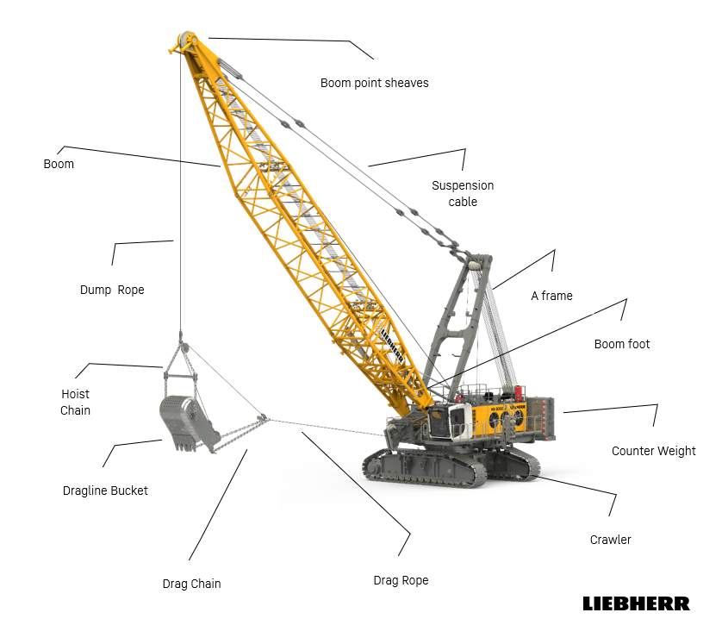
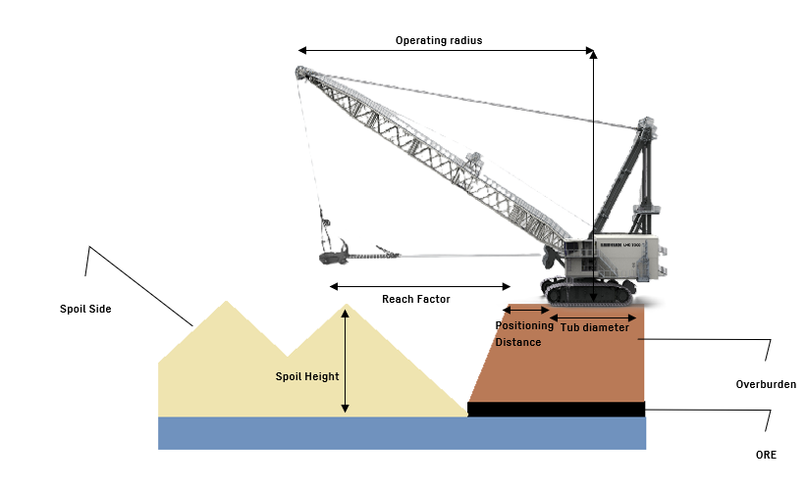

Figure 4.1 Main components and operating geometry of a dragline (Liebherr HS Series Data Sheets).

Operating parameter

- Tub Diameter : The diameter of the circular base, or tub, of the dragline. This is directly relevant to ground bearing pressure and dragline positioning geometry.
- Boom Angle : The maximum inclination of the boom above the horizontal. It affects both maximum dumping height and achievable digging depth.
- Boom Foot Height : The vertical distance from the boom foot to the operating surface of the dragline.
- Dragline Positioning Distance : The offset from the dragline’s tub centre point to the edge of the operating bench. Standard practice places the machine approximately 75% of its tub diameter back from the bench crest
- Clearance Radius : The minimum radial distance that must be kept free around the dragline’s positioning centre to ensure unobstructed and safe rotation of the boom during operation.
- Boom Foot Radius : The radius of the boom foot, which forms the structural base from which the boom projects.
- Clearance Height : The minimum vertical height required above the machine to allow safe swing or rotation of the boom without interference.
- Dumping Clearance : The distance between the bucket’s highest dumping position and the boom point end. It influences safe dumping and avoidance of bucket–boom collisions.
- Dumping Height : The vertical distance from the highest point of the dragline bucket during dumping to the operating surface level of the machine. It determines the maximum spoil pile height achievable without auxiliary rehandling.
- Boom Point Height : The vertical distance from the boom point end (where hoist ropes are suspended) down to the dragline operating level, a key determinant of digging depth and spoil placement.
- Digging Depth : The maximum vertical distance the bucket can reach below the dragline’s operating level. This defines the effective cut depth that the dragline can excavate in a single pass.
- Point Sheave Pitch Diameter : The diameter of the sheave (pulley block) that carries the main hoist rope for the dragline bucket. This dimension influences rope stresses and hoisting efficiency.
- Operating Radius: The maximum radial distance from the dragline’s positioning point within which the bucket can be effectively swung for both digging and spoil casting operations. It defines the limit of the dragline’s reach into the bench and across to the spoil pile.
- Reach Factor : The maximum horizontal distance from the bench edge to the furthest point in the spoil where the bucket can be dumped. It is a key indicator of whether a dragline can directly cast material across the highwall to the spoil side without intermediate rehandling.

Model | Engine Type | Power (kW) | Boom (Dragline, m) | Dragline Depth (m) | Dragline Bucket Capacity (m³)
HS 8040.1 | Liebherr D 944 A7-05 | 230 | 26 | 13 | 1,9
HS 8070.1 | Liebherr D 936 A7-05 | 320 | 29 | 14 | 3,8
HS 8100.2 | Liebherr D 966 A7-05 | 450 | 32 | 15 | 4,6
HS 8130.1 | Liebherr D 9508 A7-04 | 565 | 35 | 17 | 5,4
HS 8200 | Liebherr D 9512 A7-05 | 750 | 50 | 22 | 7,6
HS 8300.2 | Liebherr D 9512 A7 | 750 | 50 | 25 | 10,8

Table 4-2. Operating dimensions of Liebherr HS Series draglines (source: Liebherr Group Technical Data 2023)

Classification

Draglines can be systematically classified based on their mode of propulsion and mobility. The standard classification divides them into two broad groups: self-propelled draglines and those propelled by an external agent

Figure 4-2 Classification of draglines

Cycle of Operation

                - Bucket Positioning (Empty) - The operator moves the empty bucket to the digging location in the cut. The bucket is lowered and set in position, ready to bite into the ground.
                - Dragging and Filling - The drag rope is pulled, dragging the bucket toward the machine through the cut. As it moves, the bucket scoops and fills with material.
                - Hoisting and Swinging - Once filled, the bucket is lifted (hoisted) and swung sideways toward the spoil pile. Both motions (hoist + swing) usually occur at the same time.
Two limiting conditions can occur:
Hoist critical: Hoisting takes longer than swinging → boom must wait for bucket to reach dump height.
Swing critical: Swinging takes longer than hoisting → bucket is ready but still waiting to reach dumping position.
Productivity depends on balancing these motions so neither dominates cycle time.
                - Dumping At the spoil pile - the bucket door opens (or the bucket tips) to release material. Placement must be controlled to create a stable spoil slope.
                - Returning to Digging Position - The empty bucket is swung back toward the pit while being lowered. The operator simultaneously repositions it into the next digging spot.

- Walking Patterns in Dragline Operations
Layover (Layering Over) - Dragline waits at the end of the panel until the coal is mined. Then it turns around and starts the next panel in the opposite direction. Simple, but loses production time if coal removal is delayed.
Deadheading Dragline walks (without digging) - to the start of the next cut.
Two choices:
Walk partway → start cutting in the opposite direction.
Walk to the far end → start in the same direction as before.

- Spoil Patterns - How material is dumped creates different spoil shapes:
- Short digouts, near 90° casting → straight, uniform spoil ridge.
- Long digouts → uneven peaks instead of a smooth line.
- Mixed casting angles → ragged spoil surface but balances pile height.
Other methods:
- Radial casting → dump bucket “on the fly” while swinging → cross-bedded spoil.
- Circular casting → spreads spoil widely, reduces grading costs if enough space.

Digging Modes

Underhand

In underhand mode, the dragline removes a key cut (≈ 1.5 bucket widths) to form a clean highwall, followed by the main cut and extended bench. The key cut provides visibility, minimizes coal losses, and improves bucket fill efficiency. The machine then repositions rearward to lengthen the cut and repeat the cycle.

Key cut :- The key cut is a narrow trench about one and a half bucket width at the bottom. While excavating the key cut, the dragline sits on a line over the middle of the key cut in order to establish a clean and safe new highwall. Key cutting is usually the most difficult part to excavate due to the poorer fragmentation and lack of a third free face.

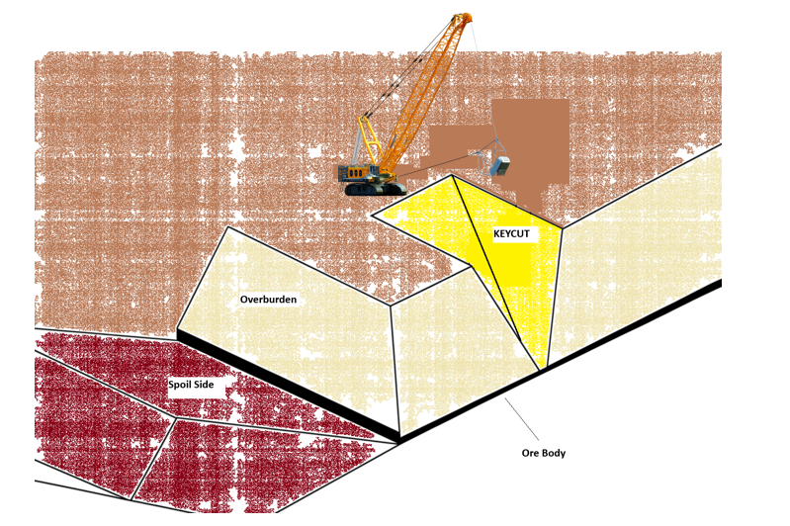
Figure 2.1- key cut in a normal underhand mode

CASTING :- The dragline is moved to the outer edge of the blasted overburden block and the remaining material is cast to the waste side.
The main reasons for this apparent time consuming action is that:
• The dragline can use its maximum reach distance; it stops the waste pushing up against the coal seam with the accompanied losses and reduces the necessity for re-handling
• Gives better visibility to the operator
• It allows for a steeper loading face to be maintained and the bucket is filled quicker and the cycle time is reduced
• The wear on the drag rope is reduced with the development of the excavation path
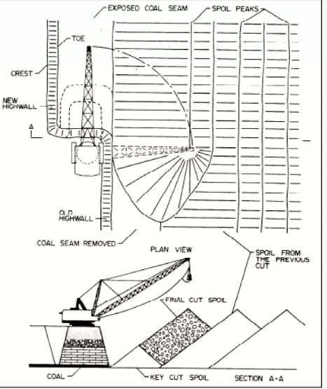
once the key cut is taken the dragline repositioning to maximize reach and minimize swing angles. The dragline moves back after casting is completed to lengthen the key cut and the cycle starts again. While dumping is taking place

Overhand

The overhand chop cutting mode is another dragline digging mode that refers to the dragline excavating material from a bench above its working bench.
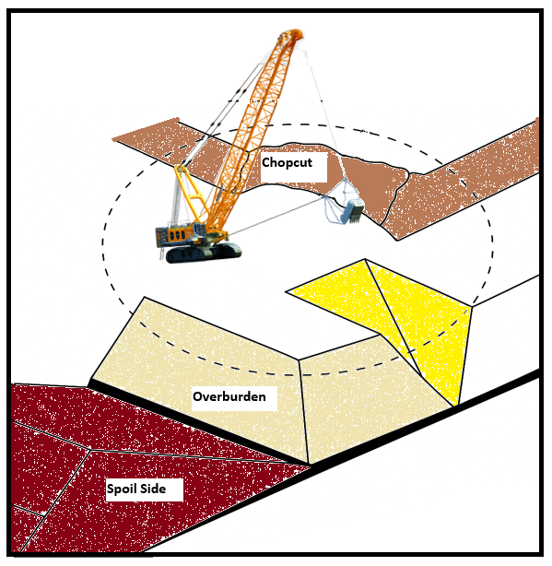
Figure 2.2- Dragline removing an advance bench in an overhand chopping mode.

- This mode of operation is frequently met in soft or undulating ground surfaces.
- In this situation, the bucket is usually held in a dump position and the teeth are dropped into the material to give the bucket penetrating force. To complete the digging procedure and filling of the bucket, the bucket is dragged downwards and towards the dragline
- The overhand chop cutting provides a stable and even working bench for the dragline in unconsolidated or rolling areas
-It also increases the maximum digging depth of the dragline (Bucyrus-Erie Co, 1977).

Disadvantages:-
- Decreases the total productivity of the dragline because the machine is working in a less efficient mode.
-The productivity losses result from longer bucket filling times, lower fill factor, longer swing angle (usually between 130 to 150 degrees) as well as increasing the dragline movements compared with normal conditions.

Spoil side & Pull back

Pull back from the spoil side is a common method in multi-pass operations or where the dragline does not have enough room to spoil all the material from a normal bridge.
- The dragline pad in the spoil side is built at a higher level than a normal bridge and closer to the spoil area .
- The technique is often used as an alternative to extended benching, particularly when the size of the dragline is insufficient to permit spoiling the material in the existing spoil room from a highwall bench.
-The dragline works in a less efficient mode than the normal mode of operation (underhand digging).

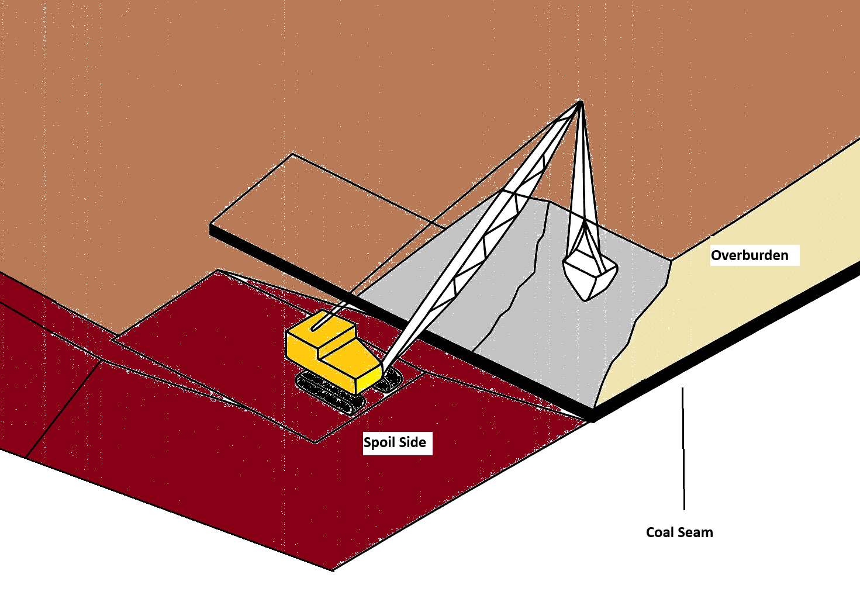
Figure 2.3- Dragline pulling back material by chopping against the highwall from a spoil side pad.
Disadvantages
- Increased dragline walking times,
- Inherent hazards of unstable spoil piles,
- Complexities of the planning and sequencing of the mining operations due to the number of different situations specially in multi-seam operations
- Additional dozing operations to prepare the dragline pad on the spoil side and the building of an additional ramp and bridge.
Spoil side stripping can result in lower productivity due to the longer swing angles and bucket fill times because of the "chopping" action of the bucket against the highwall

Stripping Casting

The main Stripping methods used are:
1. Simple side casting
2. Advance benching
3. Standard extended bench with an advance bench
4. Split bench
5. Extended key cut

Simple Side casting

Dragline placed on the main pass level surface and digging the surface of ore/coal and dropping the removed overburden in to a pile at one side. No rehandle is involved, except some rehandling around coal access ramps.
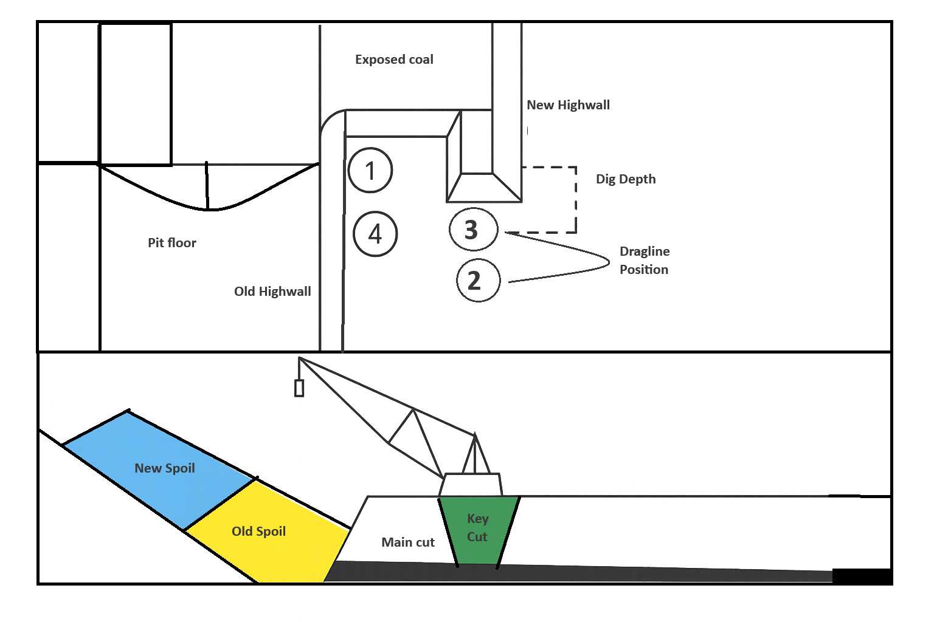
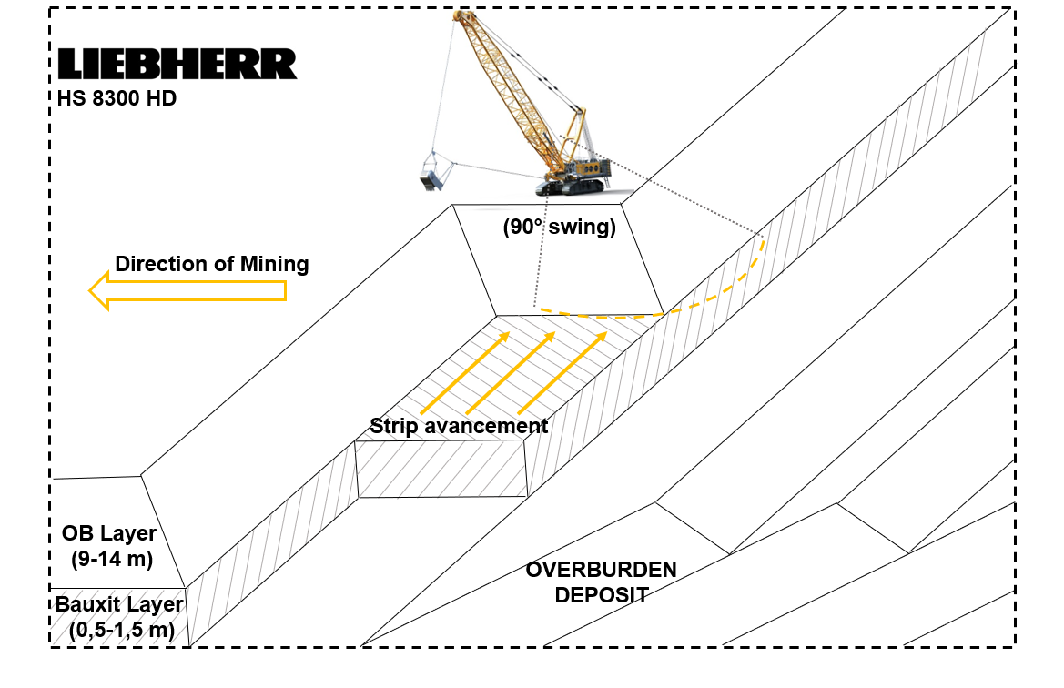
Figure -Simple side casting

Main points
- The swing angles of dragline are minimum, Applicable for shallow depth ( Shallow depth is not only the depth of the overburden, it is a relative variable which is also related to the size of the dragline used. For example, if a dragline can excavate all of the depth of overburden by Simple Side Casting, then the overburden depth can be called "shallow")
-The main disadvantage of this method is, capacity is limited and controlled by dragline geometry.

Advance Bench

It is modified of Simple casting ,When the overburden depth increases, very often, the Simple Side Casting method can be modified to an Advance Bench method to avoid rehandling.
-In this method, the level of the dragline working bench is kept lower than the original surface by forming the advance bench
Main points
- The main disadvantage of the Advance Bench is that the dragline must work in an overhand chop mode of operation
- Swing angles are greater (130 to 180 degrees) when removing an advance bench, thus reducing the dragline productivity
- There is a limitation for the height of an advance bench that a dragline can handle.
As the overburden depth increases and because of the disadvantages of chop operations, many strip mines prefer to use alternative digging methods

Extended Bench

Extended bench is used for deeper deposit, As Overburden height increases it becomes hard to dump all the overburden using the usual side casting method. This often leads to moving the same material more than once, which wastes time and money ( Rehandling % is high )

To solve this, the dragline’s reach needs to be increased. one way to do this is by placing the dragline closer to the spoil pile. This gives more space to dump the material and makes it easier to place all the overburden into the previous pit.
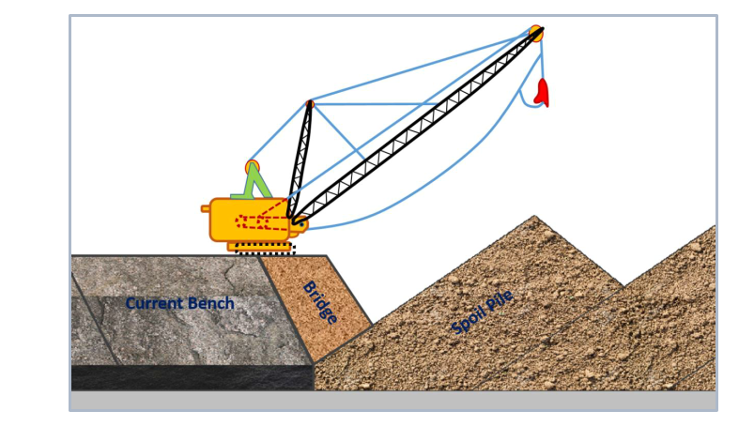
Figure 6 Extended bench (modified from Bucyrus-Erie Company Handbook,2001)
Main points
- To improve the dragline’s performance, an extended bench or bridge is often built. This bridge lets the dragline move closer to the spoil pile, helping it reach the top of the spoil more easily.
The material used to make the extended bridge is provided from both the keycut and the advance bench
-Used material is rehandling material and must be excavated later to clear the coal edge of next block
The critical factors that affect the amount of rehandle are the dragline spoiling capabilities, material swell factor, highwall angle and spoil angle.
Combine approach with this method :- It is also possible to combine the standard Extended Bench method with a throw blasting operation.

Purpose of the Method
- Increase dragline reach without modifying the machine.
- Improve spoil placement by allowing dumping at the spoil crest.
- Reduce rehandling and improve operational efficiency.
- Integrate blasting and excavation for better productivity.

Split Bench

In order to increase the maximum advance bench depth and to avoid a chop down operation, two underhand dragline passes are used in each strip.

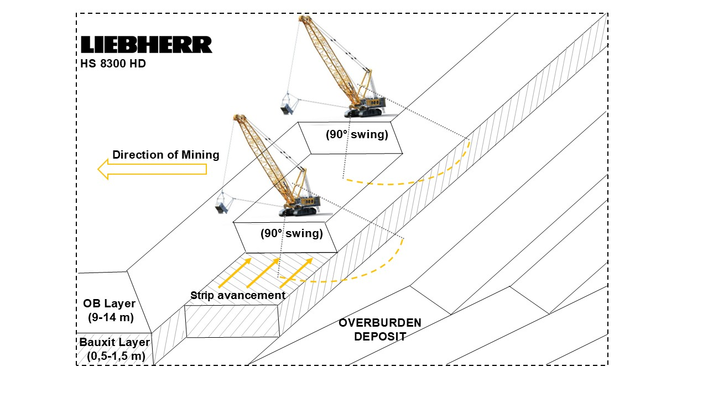
Figure 7. Split bench
bench on the lowwall side on blasted material,
-The main dig level is controlled by the maximum dig depth of the dragline and the spoil balance.
-The method involves two highwall passes using simple side casting in the first pass and a conventional extended bench in the main pass.

Extended Key cut

Two-pass operation method is extended key cut method which employing a highwall extended cut in first cut and low wall pullback operation in the second pass:
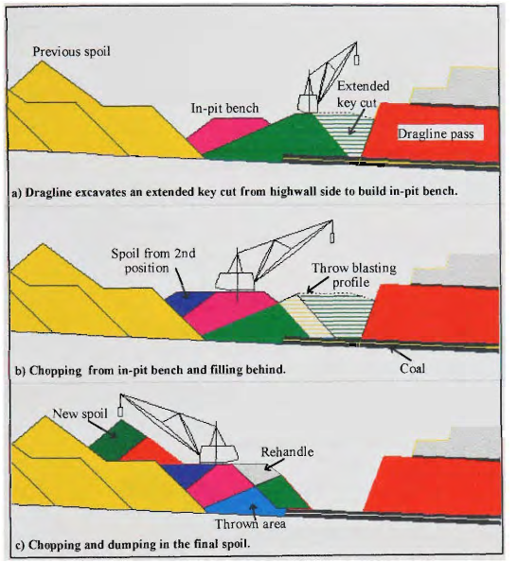
Extended Key cut

a) Dragline excavates an extended key cut from highwall side to build in-pit bench: The dragline is shown on the right (highwall) side, digging the "Extended key cut" and using that material to build the "In-pit bench" on the left.
b) Chopping from in-pit bench and filling behind: The dragline has moved onto the in-pit bench. It is now removing the remaining overburden (the "Throw blasting profile") and depositing it behind itself as "Spoil from 2nd position."
c) Chopping and dumping in the final spoil: This shows the continuation of the second pass. The dragline continues to chop down and dump the overburden, creating the "New spoil" pile. The area where the blasted material initially landed is the "Thrown area," and any material that needs to be moved again is referred to as "Rehandle."

Blasting and Fragmentation

Digging methods that rely on the dragline sitting on a stable highwall crest and performing simple, direct excavation. Blasting in dragline operations is similar to regular open-pit blasting. However, unlike shovels that push into the broken rock, draglines work by dragging their bucket across the blasted material. This means the quality of fragmentation is more important for draglines. If the rock isn't broken well, the dragline's efficiency drops much faster than a shovel working in the same conditions. As a result, good blasting is more critical for dragline operations than for shovel operations. (Morey, 1990)

As discussed in Section 3.1.4, dragline productivity is sensitive to blast fragmentation. Optimum mean fragment size is < 800 mm for efficient bucket filling. Between the two prevalent methods—stand-up blasting and throw (cast) blasting—the latter reduces re-handling by 30–60 % when geometry permit

Rehandling

In large opencast mines, draglines are predominantly employed for overburden (OB) stripping. The overall efficiency of a dragline operation is closely tied to the minimization of rehandling, i.e., the repeated movement of the same material. Rehandling not only consumes productive cycles without adding value but also inflates energy, wear, and cost metrics, thereby increasing the Total Cost of Ownership (TCO) of the equipment.

Balancing Diagram

To evaluate spoil balance, mine planners make use of the dragline balancing diagram—a geometric cross-sectional tool that represents the relative dimensions of the excavation cut, spoil void, and coal seam. This diagram provides both visual and quantitative insight into whether the volume of overburden (in bank cubic metres, BCM) removed from the active cut can be fully accommodated in the available spoil void, after accounting for swell factor and dragline dumping reach. By doing so, it links geological parameters (bench height, cut width, dip, slope) with operational parameters (bucket capacity, swing angle, spoil angle of repose, rehandle percentage).

Component of Diagram

A₁ (Excavation area): Cross-sectional area of overburden to be stripped, multiplied by swell factor to convert in-situ volume into loose cubic metres.
A₂ (Spoil area): Geometrically available void for dumping, constrained by dragline dump radius, spoil slope, and highwall geometry.
A₃ (Balance factor): A3=A1×S−A2

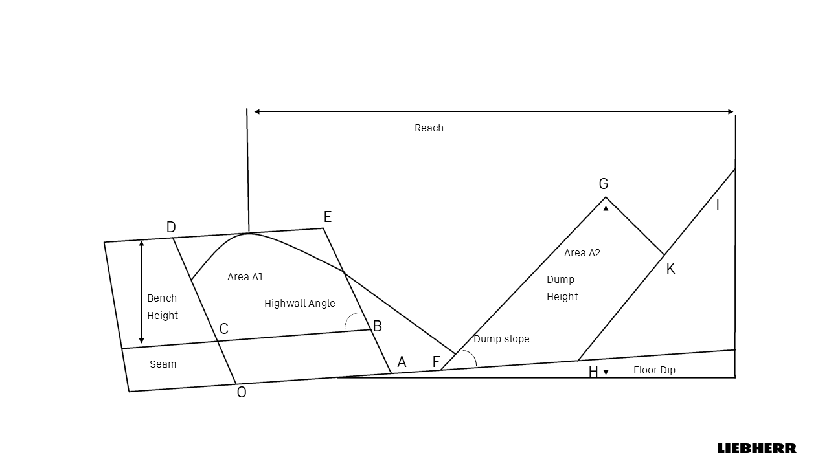
Dragline Balancing Diagram

Area A1 = BCDE = Bench width x Bench Height
Area A2= FHKG = FHIG-GKI
A3=A1×S−A2
where S is the swell factor.
  - A₃ < 0: Surplus spoil capacity; cut width/bench height can be optimized upward.
  - A₃ = 0: Balanced condition; no rehandling.
  - A₃ > 0: Excess OB beyond spoil void; rehandling required.
Example Balancing diagram
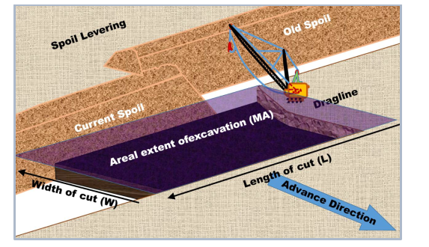
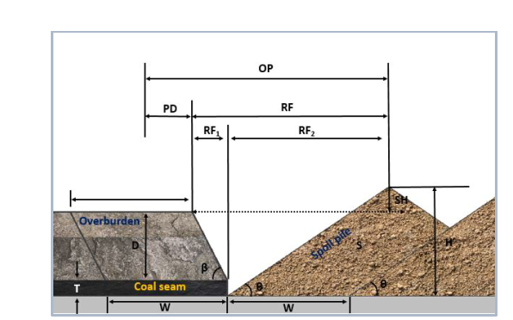
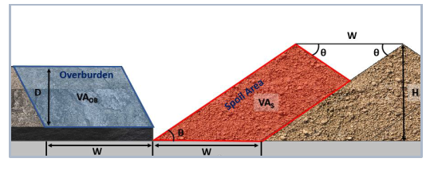

Figure 4-5. Typical dragline balancing diagram (adapted from Karpuz & Demirel 2016; CMPDI Design Guide 2022)

Over burden Area VAob- = 𝑾 × 𝑫 × 𝑳
Spoil Area 𝑽𝑨𝒔 = 𝑽𝑨𝑶𝑩 × 𝑺𝑭

𝑽𝑨𝑶𝑩 = 𝑾 × 𝑫 × 𝟏 | 1 Volume of spoil -SFx Wx Dx1
Width of Ob- W Pit width (m)  Height of Ob- D Overburden thickness (m)  LENGTH – L(1) 𝑳: Length of cut (m) | 2 volume of spoil from diagram-  𝑽𝑨𝒔 = 𝑾 × 𝑯 − (𝑾 /𝟐 )² × 𝒕𝒂𝒏𝜽 × 𝟏  𝑾: Pit width (m)  𝑯: Height of spoil pile (m)  𝜽: Spoil pile angle (degree)

By balancing approach
𝑾 × 𝑯 − (𝑾 /𝟐 )² × 𝒕𝒂𝒏𝜽 = 𝑾 × 𝑫 × SF……………..1
Height of spoil | H=Dx SF​+W/4 x tanθ
Stacking Height (the difference of bench height and spoil pile) | 𝑺𝑯 = 𝑯 − (𝑫 + 𝑻)
Reach Factor | 𝑹𝑭 = 𝑹𝑭𝟏 + 𝑹𝑭𝟐 = 𝑫/𝒕𝒂𝒏𝜷 +𝑯/𝒕𝒂𝒏𝜽 𝜷: Pit slope angle (degree)
Operation Radius: | 𝑶𝑹 = 𝑹𝑭 + 𝑷𝑫

Functions of the Balancing Diagram

According to Indian and international research:
- Coal exposure estimation: Calculates how quickly and efficiently coal is uncovered per cut.
- Dragline workload allocation: Balances tasks across multiple machines depending on productivity.
- Rehandling estimation: Identifies % of OB that must be handled twice.
- Bench design: Provides guidance on optimum bench height and cut width for reduced unit cost.
- Mine planning integration: Used in simulation models (CADSIM, DRGX, MINESCAPE) for strip layout and pit optimization.

Production and Influencing Factor

Draglines are among the most efficient earthmoving machines used in surface mining. In India, they dominate overburden (OB) stripping in coalfields and are being evaluated for non-coal sectors—such as phosphates, limestone, and bauxite—where high stripping ratios and low-carbon excavation are priorities (CIL 2024; CMPDI 2023). Their ability to directly cast material from highwall to spoil without intermediate haulage achieves unit costs typically lower than truck–shovel fleets under favorable geometry .

However, field performance often falls short of rated capacity due to extended cycle times, poor blast fragmentation, and operational delays. Hence, realistic production modeling and quantitative factor evaluation are essential inputs to Total Cost of Ownership (TCO) analysis

Production formula and Factors

Annual Production ( m³/Year)
Q= Cb × Ff × SF× ( 3600 / C ) × M × (Ns × Nh × Nd) × A × U
where:
- Cb= rated bucket capacity (m³)
- Ff = bucket fill factor SF = swell factor (loose/bank)
- C = average cycle time (s)
- M = travel/position factor
- A= Mechanical Availability U= Utilization
- Ns = shifts/day, Nh = hours/shift, Nd = operating days/year.

Production Factor Influence

  - Bucket Capacity- The Volume of bucket is direct proportional to total production

Rathi, P.D. Opencast Mine Planning, Deployment of HEMM for Optimum Utilisation, Total Technical Parameters of HEMM Including Limitations, and Haul Road & its Maintenance.

  - Fill Factor and Swell factor – Dragline Productivity dependent on material behavior. Two parameters are particularly critical in this regard: the swell factor (SF) and the fill factor (Ff).

    - Influence of Rock Type - The swell factor is defined as the ratio between the volume of fragmented rock in a loose state and its original in-situ bank volume, while the fill factor expresses the proportion of the rated bucket capacity actually filled during operation. Both vary significantly with Lithologe.
Rock | Swell | Swell factor | Fill Factor
Asbestos ore | 1,4 | 0,71 | 0,85
Basalt | 1,6 | 0,62 | 0,8
Bauxite | 1,35 | 0,74 | 0,9
Chalk | 1,35 | 0,76 | 0,9
Clay (dry) | 1,25 | 0,8 | 0,85
Clay (light) | 1,35 | 0,76 | 0,85
Clay (heavy) | 1,35 | 0,74 | 0,8
Clay and gravel (dry) | 1,3 | 0,76 | 0,85
Clay and gravel (wet) | 1,35 | 0,74 | 0,8
Coal (anthracite) | 1,35 | 0,74 | 0,9
Coal (bituminous) | 1,35 | 0,74 | 0,9
Coal (lignite) | 1,3 | 0,76 | 0,9
Copper ore (low-grade) | 1,5 | 0,66 | 0,85
Copper ores (high-grade) | 1,6 | 0,62 | 0,8
Earth (dry) | 1,3 | 0,76 | 0,95
Earth (wet) | 1,3 | 0,76 | 0,9
Granite | 1,55 | 0,64 | 0,8
Gravel (dry) | 1,25 | 0,8 | 1
Gravel (wet) | 1,35 | 0,74 | 1
Gypsum | 1,5 | 0,66 | 0,85
Limenite | 1,4 | 0,71 | 0,85
Iron ore 40% Fe | 1,4 | 0,71 | 0,8
Iron ore – 40% Fe | 1,45 | 0,68 | 0,8
Iron ore – 60% Fe | 1,55 | 0,64 | 0,75
Iron ore (taconite) | 1,65 | 0,6 | 0,75
Limestone (hard) | 1,6 | 0,62 | 0,8
Limestone (soft) | 1,5 | 0,66 | 0,85
Manganese ore | 1,45 | 0,68 | 0,85
Phosphate rock | 1,5 | 0,66 | 0,55
Sand (dry) | 1,5 | 0,86 | 1
Sand (wet) | 1,15 | 0,86 | 1
Sand and Gravel (dry) | 1,15 | 0,86 | 1
Sandstone (porous) | 1,6 | 0,62 | 0,8
Sandstone (cemented) | 1,6 | 0,62 | 0,8
Shales | 1,45 | 0,68 | 0,8

Some properties for various materials which are important for loading machine evaluation.
Atkinson (1971), Atkinson (1992).

    - Interaction with Bucket Capacity- The relationship between bucket size, swell factor, and fill factor is illustrated in Figure, where two rock conditions were modelled: one representing harder overburden (50% Category III + 50% Category IV) and another representing softer conditions (90% Category III + 10% Category IV).
Two insights are evident. First, the fill factor increases with bucket capacity.. Second, the swell factor remains relatively constant across capacities, confirming that muck looseness is primarily dictated by geology and blasting, not by bucket size. Thus, while capacity upgrades improve filling efficiency, they cannot compensate for adverse swell conditions.

Rathi, P.D. Opencast Mine Planning, Deployment of HEMM for Optimum Utilisation, Total Technical Parameters of HEMM Including Limitations, and Haul Road & its Maintenance.

    - Effect of Blasting Practices- Controlled blasting strongly influences dragline productivity. Overblasting increases swell and decreases bucket fill, while underblasting leaves oversized boulders
Empirical values (Table 5-2) indicate that moderate blasting achieves optimum balance—fill ≈ 0.85, swell ≈ 0.75.
Overburden Conditions | Swell Factor | Bucket Fill Factor
Light Blasting | 0.81 | 0.85–0.90
Medium Blasting | 0.75 | 0.80–0.90
Heavy Blasting | 0.71 | 0.75–0.85
Bad Fragmentation | 0.69 | 0.70–0.75

Atkinson (1971), Atkinson (1992).

  - Cycle Time - cycle time (C), defined as the average time required to complete one full digging and dumping sequence
dragline cycle can be decomposed into four distinct phases:
- Placement and Digging (Tpd): The bucket is lowered, positioned, and dragged through the muck pile until filled.
- Swing to Spoil (Ts): The bucket is hoisted and swung towards the spoil area, often performed concurrently with hoisting.
- Dumping (Td): The bucket is tipped or the dump door opened to release material at the spoil crest.
- Return Swing and Lowering (Tr): The empty bucket is swung back and lowered into the digging position.
Thus, the total cycle time is expressed as:
C= Tpd +Ts +Td + TrC

- Theoretical Cycle Times - Theoretical cycle times for draglines of varying bucket capacities under different swing angles. It is evident that as swing angle increases, cycle time rises almost proportionally, regardless of bucket size.

 | Theortical cyle time
Bucket size | Swing Angle
(m³) | 90° | 120° | 150° | 180°
up to 15 | 55 | 62 | 69 | 77
16–26 | 56 | 63 | 70 | 78
27–44 | 57 | 64 | 71 | 79
45–57 | 59 | 65 | 72 | 80
58–92 | 60 | 66 | 73 | 81
93–150 | 62 | 69 | 76 | 84

Theoretical Cycle Time According to Dragline Operation Swing Angles and Bucket Size
(Source: Karpuz and Hindistan (2005) in Eskikaya et al. (2005))

    - Mechanical Availability and Utilization –

Availability (A) refers to the proportion of scheduled time during which the machine is in a mechanically operable state, regardless of whether it is actually producing. It accounts for losses caused by both planned and unplanned downtime.
A = [ SSH – (MH + BH) ] / SSH

An availability of 0.85, for example, indicates that 85% of the scheduled time the machine was ready to operate, while the remaining 15% was lost to maintenance and breakdowns

Utilization (U) extends this concept by measuring the fraction of scheduled hours during which the dragline is not only available but also productively working. In addition to downtime, it subtracts idle delays when the machine is operational but cannot be used due to mine-side constraints. no blasted muck available,
- delays in floor preparation,
- power interruptions,
- shift-change activities,
- cable handling and relocation.
Thus, utilization is always lower than availability, since it accounts for both machine-related and external constraints.
U = [ SSH – (MH + BH + IH) ] / SSH
SSH = scheduled shift hours,
MH = maintenance hours,
BH = breakdown hours,
The multiplication of A and U is Operating efficiency
 | Utilization
Availability | Excellent | Good | Fair | Poor
Excellent | 0.84 | 0.81 | 0.76 | 0.7
Good | 0.78 | 0.76 | 0.71 | 0.64
Fair | 0.72 | 0.69 | 0.65 | 0.6
Poor | 0.63 | 0.61 | 0.57 | 0.52

Dragline Operating Efficiency , Source Humphrey 1990
Case study -This is example for SCCL Mines
Mine Equipment | Scheduled shift hours (SSH) | Working hours (WH) | Maintenance hours (MH) | Breakdown hours (BH) | Idle hours (IH) | Availability factor (A) | Utilization factor (U)
15/90 | 720 | 501 | 161 | 32 | 26 | 0.7319 | 0.6958
24/96 | 720 | 619 | 59 | 25 | 17 | 0.8833 | 0.8597
24/96 | 744 | 594 | 49 | 68 | 33 | 0.8427 | 0.7983
24/96 | 720 | 507 | 119 | 33 | 61 | 0.7888 | 0.7041
30/92 | 744 | 408 | 137 | 30 | 161 | 0.7755 | 0.5483

    - Travel/position factor ( M)

Draglines are largely stationary over multiple cycles and only relocate after completing a panel or key cut. However, two categories of losses are always present:

Travel losses: Downtime incurred during dragline walking between adjacent panels, extended benches, or repositioning within the cut. Although infrequent, each walk may take 30–60 minutes, reducing effective working time.
Mt=1− Walking hours/ Scheduled operating hours
​
Spotting/positioning losses: Small but frequent time penalties when the bucket is not ideally positioned at the toe during digging, or overshoots the spoil crest during dumping. Spotting corrections extend cycle time and reduce fill efficiency.

Mp​=1− Spotting correction time​ / Cycle time

M=Mt​×Mp​

Other Factor

Additional variables—such as panel width, bench height, and cut geometry—affect dragline output by altering swing angle, rehandle, and dump reach. Environmental and regulatory factors (e.g., monsoon downtime, slope restrictions) also reduce effective annual productivity by 3–8 % (DGMS CMR 2017; CMPDI 2020).

Mining cases and Observation

- Effect of depth of cut on digging time:-

Fig. 6—Influence of collar oversize on the digging time for different capacity draglines source NCL

- Verious factor and effect on productivity –
CMPDI (2005–2023) performance analyses for NCL and SCCL draglines highlight that bucket capacity, swing angle, and rock category jointly determine achievable annual output. Two representative cases are reproduced below.

CASE 1-
ANNUAL PRODUCTIVITY OF WALKING DRAGLINES AND VARIABLES FOR ITS CALCULATION
 | ROCK CLASS - 50% Cat III + 50% Cat IV
 |  |  | Bucket cycle time  IN Min |  | PRODUCTIVITY OF  DRAGLINE Million M3
Bucket Capacity (m³) | Swell Factor | Bucket Fill Factor | 90° Swing | 120° Swing | 90° Swing | 120° Swing
4 | 0,719 | 0,867 | 1,227 | 1,353 | 0,51 | 0,463
5 | 0,719 | 0,871 | 1,227 | 1,353 | 0,641 | 0,581
6,1 | 0,719 | 0,874 | 1,227 | 1,353 | 0,784 | 0,711
6,9 | 0,719 | 0,877 | 1,227 | 1,353 | 0,89 | 0,807
8,4 | 0,719 | 0,883 | 1,227 | 1,353 | 1,091 | 0,989
10 | 0,719 | 0,888 | 1,227 | 1,353 | 1,306 | 1,184
11,5 | 0,719 | 0,894 | 1,227 | 1,353 | 1,512 | 1,371
12 | 0,719 | 0,896 | 1,227 | 1,353 | 1,581 | 1,434
14 | 0,719 | 0,903 | 1,227 | 1,353 | 1,859 | 1,686
15 | 0,719 | 0,906 | 1,227 | 1,353 | 1,999 | 1,813
16 | 0,719 | 0,91 | 1,227 | 1,353 | 2,141 | 1,942
20 | 0,719 | 0,924 | 1,227 | 1,353 | 2,718 | 2,465
24 | 0,719 | 0,938 | 1,227 | 1,353 | 3,311 | 3,003
26 | 0,719 | 0,946 | 1,227 | 1,353 | 3,618 | 3,218
27 | 0,719 | 0,949 | 1,227 | 1,353 | 3,769 | 3,418
29,8 | 0,719 | 0,959 | 1,227 | 1,353 | 4,203 | 3,812
31 | 0,719 | 0,963 | 1,227 | 1,353 | 4,391 | 3,982
32 | 0,719 | 0,967 | 1,227 | 1,353 | 4,551 | 4,127
Rathi, P.D. Opencast Mine Planning, Deployment of HEMM for Optimum Utilization, Total Technical Parameters of HEMM Including Limitations, and Haul Road & its Maintenance.

CASE 2-
ANNUAL PRODUCTIVITY OF WALKING DRAGLINES AND VARIABLES FOR ITS CALCULATION
ROCK CLASS- 90% Cat III + 10% Cat IV
 |  |  | Bucket cycle time  In Min |  | PRODUCTIVITY OF  DRAGLINE Million M3
Bucket Capacity (m³) | Swell Factor | Bucket Fill Factor | 90° Swing | 120° Swing | 90° Swing | 120° Swing
4 | 0,732 | 0,88 | 1,176 | 1,303 | 0,55 | 0,496
5 | 0,732 | 0,884 | 1,176 | 1,303 | 0,691 | 0,623
6,1 | 0,732 | 0,887 | 1,176 | 1,303 | 0,845 | 0,763
6,9 | 0,732 | 0,89 | 1,176 | 1,303 | 0,959 | 0,866
8,4 | 0,732 | 0,896 | 1,176 | 1,303 | 1,176 | 1,061
10 | 0,732 | 0,901 | 1,176 | 1,303 | 1,408 | 1,27
11,5 | 0,732 | 0,907 | 1,176 | 1,303 | 1,68 | 1,471
12 | 0,732 | 0,909 | 1,176 | 1,303 | 1,704 | 1,538
14 | 0,732 | 0,916 | 1,176 | 1,303 | 2,003 | 1,808
15 | 0,732 | 0,919 | 1,176 | 1,303 | 2,154 | 1,944
16 | 0,732 | 0,923 | 1,176 | 1,303 | 2,307 | 2,082
20 | 0,732 | 0,937 | 1,176 | 1,303 | 2,928 | 2,642
24 | 0,732 | 0,951 | 1,176 | 1,303 | 3,566 | 3,218
26 | 0,732 | 0,959 | 1,176 | 1,303 | 3,895 | 3,516
27 | 0,732 | 0,962 | 1,176 | 1,303 | 4,058 | 3,662
29,8 | 0,732 | 0,972 | 1,176 | 1,303 | 4,525 | 4,084
31 | 0,732 | 0,976 | 1,176 | 1,303 | 4,727 | 4,266
32 | 0,732 | 0,98 | 1,176 | 1,303 | 4,899 | 4,422
Rathi, P.D. Opencast Mine Planning, Deployment of HEMM for Optimum Utilization, Total Technical Parameters of HEMM Including Limitations, and Haul Road & its Maintenance.

Cost Modal - Total Cost of Ownership

The deployment of draglines in surface mining—especially within coalfields and large non-coal deposits—demands not only a rigorous technical evaluation but also a comprehensive economic analysis due to their exceptionally high capital investment.
The Total Cost of Ownership (TCO) framework provides a holistic basis for evaluating dragline economics. Unlike simple capital comparisons, TCO encompasses the entire life cycle—from acquisition and assembly to operation, maintenance, rebuilds, and decommissioning
For mining applications, TCO is typically expressed as a unit cost (₹/m³ or ₹/t of coal exposed).

The TCO structure comprises four interrelated elements:
- Ownership costs – fixed, time-based charges including CAPEX, depreciation, average investment, and IIT (Interest, Insurance, and Taxes).
- Operating costs – variable, utilisation-dependent charges such as labour, energy, consumables, ropes, preventive maintenance, and rebuilds.
- Unit cost metrics – normalised cost per bank m³ or tonne, allowing benchmarking across systems.
- Discounted Average Cost (DAC) – NPV-based comparator for long-term projects.

Ownership cost

Ownership costs represent the fixed annualized financial obligations associated with owning and maintaining the dragline, irrespective of its utilization level. These are computed annually and expressed on a per-m³ basis of overburden handled

        - Capital Expenditure (CAPEX)
CAPEX comprises the upfront investment required to procure, transport, assemble, and commission the dragline. For a HS 8300-class machine, CAPEX typically ranges between ₹600–900 crore in Indian conditions.

Disaggregated Components of CAPEX-Purchase Price (OEM) Shipping & Transport, Erection & Assembly, Civil Works & Infrastructure, Commissioning & Testing
In India, dragline procurement involves long lead times (3–5 years from tender to commissioning), meaning CAPEX planning must integrate financing, exchange rate risk, and government approval cycles.

        - Depreciation (D)
Depreciation allocates the CAPEX over the economic life of the dragline (20–30 years). Different methods alter cost profiles:

Method | Formula | Key Mining Application | Notes
Straight-Line (Fixed Depreciation) | D = (Cp - S) / n | Used in Coal India Ltd. (CIL), CMPDI feasibility studies. | Cp = Purchase cost of the machine (CAPEX)  S = Salvage value  n = Useful service life (years)  D = Annual depreciation  Dt = Depreciation charge in year t  BV(t-1) = Book value of the machine at the beginning of year t  r = Depreciation rate  Qtot = Total expected lifetime output  Qyear = Actual annual output in that year  t = Year number
Written Down Value (WDV) | Dt = BV(t-1) × r | Applied for taxation in Indian mines under Income Tax Act.
Units-of-Production | D = (Cp - S) / Q tot × Q year | Used in international dragline models (Australia, USA).
Sum-of-the-Years’-Digits (SYD) | Dt = (n - t + 1) / [n(n+1)/2] × (Cp - S) | Occasionally used in feasibility modelling for mines.
Double Declining Balance (DDB) | Dt = 2 × (1/n) × BV(t-1) | Rare in mining feasibility but seen in global mining finance.

n = Useful service life (years) for dragline is range between 18-28 Years

For dragline Straight-Line (Fixed Depreciation)

(d) Annual Interest, Insurance, and Taxes (IIT)
Annual Investment and Interest on Investment: Instead of calculating interest on the initial purchase price, the concept of Annual (Average) Investment (AAI) is used. This reflects the mean book value of the machine over its economic life.
AAI = (n+1) / (2n) × Cp
Here:
AAI = Annual Average Investment
Cp = Purchase cost of the machine (CAPEX)
n = Useful life in years ( 18-28 years)
Interest Insurance and Taxes (IIT): Interest, Insurance, and Taxes (IIT) is a consolidated cost block included in the ownership cost of high-CAPEX mining equipment such as draglines.
IIT=rIIT​×AAI
- r_IIT = Combined flat rate (typically 10–15%)

In CMPDI cost norms, a bundled IIT rate of 15 % of AAI is used, while international models separate components

Hence, Ownership Cost (OC) =D+IIT

Operating cost

Operating costs dominate over the long life cycle of a dragline and are highly sensitive to utilisation (U), availability (A), energy consumption, and maintenance quality.

Key components include
(a) Labour (LC)
Labour cost covers operators, helpers, maintenance crews, and supervisors.
Formula:
LC=(Nop Wop+NhpWhp+NmtWmt+NsupWsup)×S
Where:
- Nop = Number of operators per shift
- Wop = Annual wage per operator
- Nhp = Number of helper per shift
- Whp = Annual wage per helper
- Nsup = Supervisory staff
- Wsup = Annual wage per supervisor
- Nmt = Maintenance staff
- Wmt = Annual wage per maintenance staff
- S = Number of shifts per year
(b) Energy (EC)
For electric draglines (dominant in India):
EC=P×H×Ce
Where: P = avg. power (kW), H = annual hours, Ce= tariff (₹/kWh).
For diesel-based draglines:
EC=F×H×Cf
Where F = L/h consumption, ​ Cf = ₹/L diesel.
energy typically represents 25–35 % of total annual OPEX for electric draglines (CMPDI 2023).

Other cost
- Lubricants and Consumables (LCn): Oils, greases, hydraulic fluids.
- Spare Parts and Components (SP): Replacement of motors, gears, chains, etc.
- Wire Ropes and Drag Chains (WR): Major recurring expense.
- Preventive Maintenance (PM): Scheduled inspections and minor overhauls.
- Major Rebuilds (RB): Life-extension programs every 8–12 years.

(c) Lubricants & Consumables ( LCN)
Based on Liebherr maintenance data (HS 8300), lubricant cost correlates inversely with total energy cost
Via using Empirical regression for HS 8300 dragline maintenance data :
Lube% of energy=548.8/EC

This indicates that as energy cost rises, the percentage share of lubrication cost falls, stabilising near 5–6%.

(d) Maintenance & Spares (SP+WR+PM)
Maintenance cost is strongly correlated with energy cost and operating hours. For HS 8300 machines:
Maintenance % of energy=285.0 * EXP(-0.012084*Energy cost+ 1.8e 05*WorkingHours)

(R² ≈ 0.97, based on operational regression data).

(e) Major Rebuilds or breakdown cost (RB)
Draglines require life-extension rebuilds every 8–12 years, costing 20–30% of CAPEX. Averaged annually, rebuilds ≈ 2% of CAPEX/year.

Thus, annual operating cost (OPC) = Labour cost+ Energy cost+
maintenance cost+ Major rebuilds
Total cost (TC)= Annual ownership cost (OC) + Annual operating cost (OPC)

Indicative cost distribution

CAPEX Component | Typical Share (%) | Notes
Purchase Price | 60–70% | Dominant, covers OEM supply of dragline
Shipping & Transport | 5–10% | Depends on distance, import duties
Erection & Assembly | 10–15% | High due to site complexity and long erection cycle
Civil Works & Infra | 5–8% | Substations, pads, roads, drainage
Commissioning & Testing | 2–3% | Trial runs, reliability checks

Component IIT | General Consideration | Typical Percentage Range
Interest | Cost of capital or opportunity cost; usually based on WACC or RBI lending rate. | 8–12 %
Insurance | Annual premium for coverage against damage, accidents, natural hazards. | 0.5–1.5 %
Taxes | Statutory levies, machinery/property tax, GST on insurance. | 1–2 %
Bundled IIT (India) | CMPDI/CIL apply a flat rate instead of separating components. | 10–15 % (combined)

Component Lube , Maintenance and Breakdown | India (CMPDI/Thesis Practice for big machinery ) 25 year | HS 8300
Lubricants & Consumables (LCn) | ≈30% of Energy cost (rule of thumb) | 3-13 % of Energy cost ( 10-18 years)
Maintenance (SP, WR, PM) | ≈20% of depreciation (bundled rule of thumb) | 61-226 % of Energy cost ( 10-18 years)
Breakdowns & Major Rebuilds (RB) | ≈2% of CAPEX/year averaged (or 20–30% per cycle every 8–12 years) | No separate Data available

Unit cost

To benchmark across mines:
- Unit Cost per m3=(OC+OPC)/Qannual
- Unit Cost per tonne=(OC+OPC)/Qannual in ton
- Unit Cost per tonne ore =(OC+OPC)/Qannual ore in ton

TCO Tool development

Draglines are capital-intensive assets in Indian surface coal mining, with acquisition and commissioning costs that can reach several hundred crore rupees. Their economic justification relies on the ability to move large volumes of overburden at the lowest unit cost (₹/m3).

Introduction and Objective

Conventional feasibility studies often evaluate draglines either on production capacity or on cost elements, without integrating both into a lifecycle decision-support framework.

The tool development was guided by four objectives:
1. To create a transparent, modular framework for dragline TCO.
2. To integrate production, cost, and ESG (energy, carbon) dimensions into a single evaluation platform.
3. To implement cost allocation at both annual and discounted NPV levels.
4. To enable direct comparison between dragline and truck–shovel systems.

The purpose of this chapter is to present the Unified Mining Analysis – Dragline TCO Tool , developed as a web-based application. The tool integrates:
- Production equations (cycle-time based, adjusted for availability and utilization),
- Ownership and operating cost accounting,
- Energy and emissions intensity, and
- Discounted cash-flow economics (NPV and payback).

This module supports direct benchmarking of draglines against truck–shovel systems, under operating and cost conditions

Technical Specifications of TCO Tool

- System Architecture
- The tool is a client-side web application (HTML5/JS/CSS) with three layers:
- Interface: input panels, dashboards, export functions.
- Computation: cycle-based production models, cost equations, regression for lube & maintenance.
- Output: KPI dashboard, cost & ESG charts, auto-generated Word reports.
- Module Workflow (8 steps)
- Equipment setup (dragline, shovel, truck, dozer).
- Material & OEE inputs (density, swell, fill, A, U, M).
- Cycle modelling (swing, haul, pass).
- Production outputs (m³/h, m3/year).
- Cost inputs (CAPEX, OPEX, ownership, regressions).
- ESG (energy, CO₂ intensity, carbon cost).
- Economics (NPV, payback, cashflow).
- Dashboard & executive summary.
- Default Parameters
- Dragline: 10.8 m³ bucket, 54 s cycle, A = 0.88, U = 0.78, life 20.5 y, energy 70 kWh/h.
- Shovel–truck: 5.4 m³ shovel, 60 m³ truck, life 10–17 y.
- Dozer: 38.4 m³ blade, A = 0.90, U = 0.80, life 18 y.
- System Requirements
- Runs in Chrome/Firefox/Edge.
- ≥ 2 GHz dual-core CPU, 4 GB RAM, <50 MB storage.
- Innovation
- Integrates production, cost, and ESG in one tool.
- Benchmarks dragline vs truck–shovel vs dozer.
- Exports structured reports for feasibility studies.

Module work flow of Dragline

- Step 1 – Equipment Configuration: Users define system assets: draglines (bucket, cycle, method), Quantities and specifications are entered to model heterogeneous fleets.
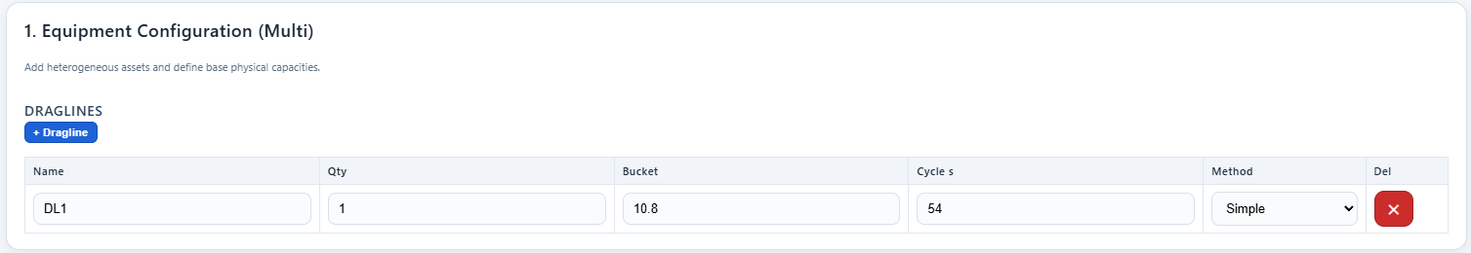

- Step 2 – Material, OEE & Calendar: Inputs include material density, swell factor, calendar hours, availability, utilization, fill factor, spotting factor, and rehandling parameters.

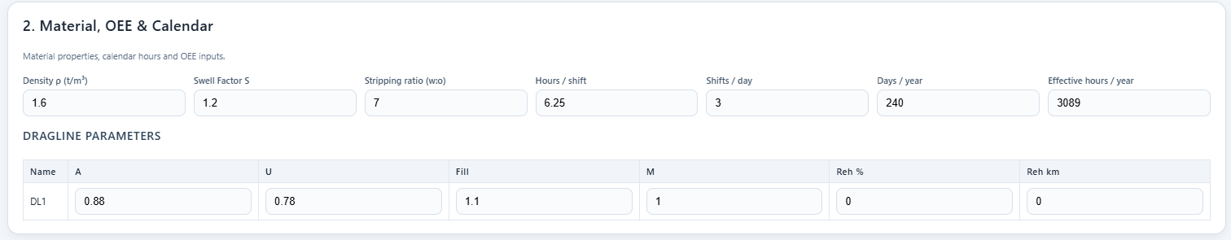

- Step 3 – N/A for dragline

- Step 4 – Production (LCM): Hourly and annual production are computed from cycle-based equations. Outputs include dragline m³/h, annual bcm, and coal tonnes exposed.
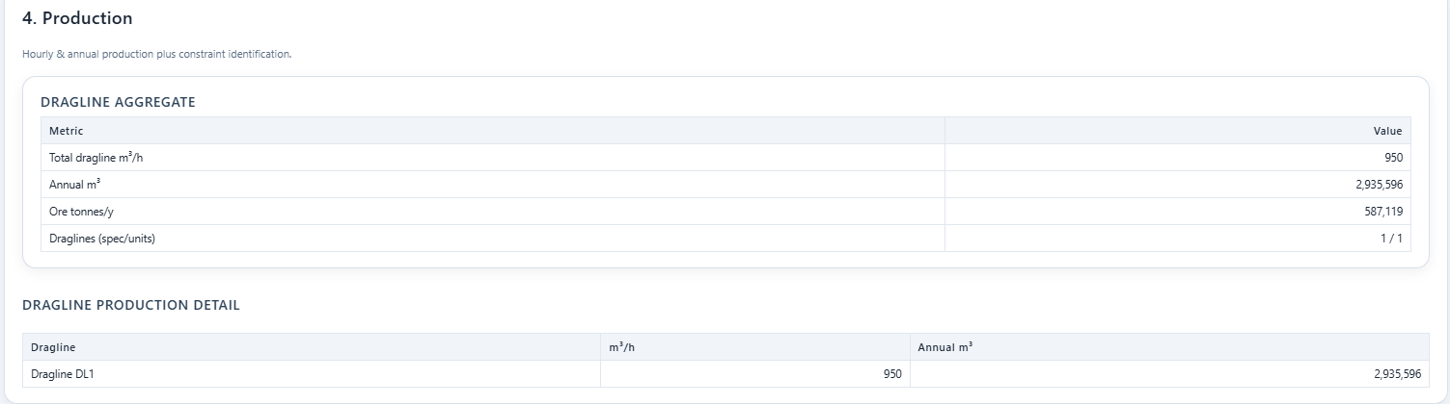

- Step 5 – Cost Inputs & Ownership: CAPEX, OPEX, salvage, operator costs, energy consumption, maintenance, and breakdown reserves are entered. Outputs: Ownership + OPEX totals.

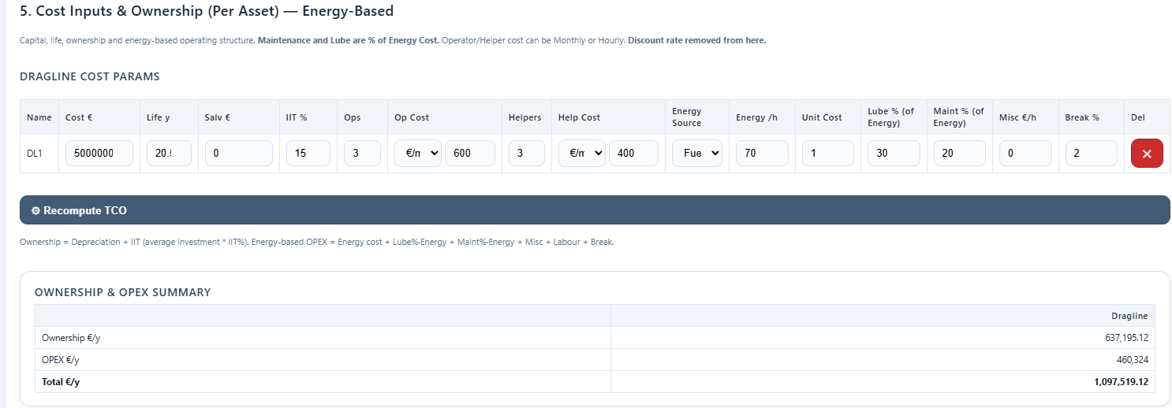

- Step 6 – ESG & Unit Economics: Environmental and energy parameters applied: carbon emission factor, carbon pricing, and fuel consumption. Outputs: production cost, carbon intensity, climate contribution.

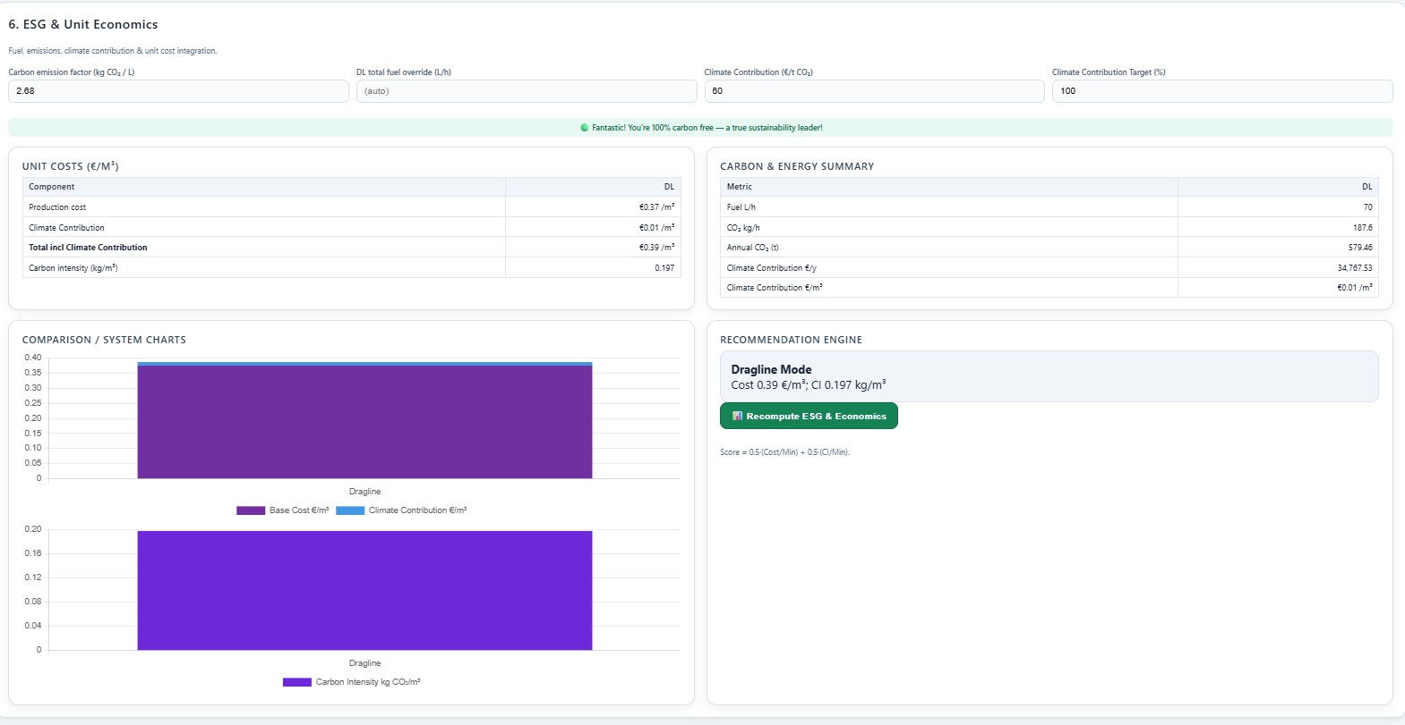

- Step 7 and Step 8– Economic Evaluation (NPV & Payback) and Executive Summary snapshot : Discounted cash-flow analysis using commodity price, discount rate, project life, salvage, and escalation. Outputs: NPV, payback period, margin. And cost €/m3, Climate contribution
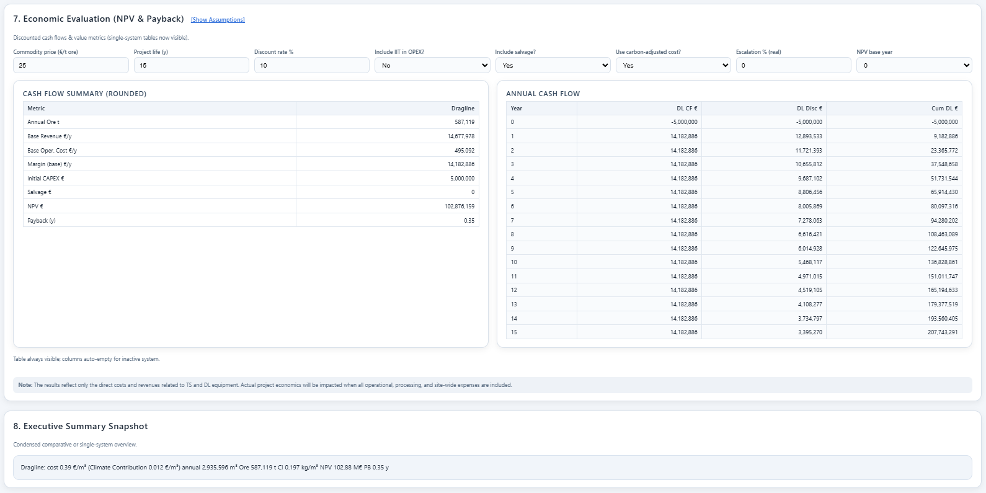

KPI Dashboard Output

The final Result of the TCO Tool provides a KPI Dashboard, which consolidates all production, cost, and ESG indicators into a single decision-support interface (Figure 6.X). Results are expressed in user-defined currencies (₹/€, USD) with real-time exchange rate scaling.

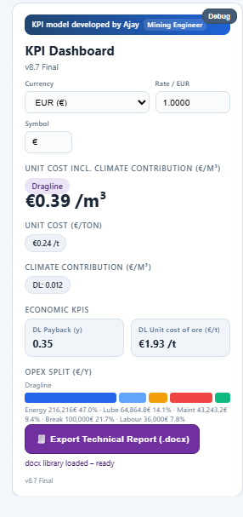
Example -
- Tco Outputs:
- Unit Cost Incl. Climate Contribution (€/m³): €0.39/m³
- Unit Cost (€/ton): €0.24/t.
- Climate Contribution (€/m³):€0.0012/m³.
- Economic KPIs:
- Payback period: 0.35 years.
- Unit cost of ore exposure: €1.93/t.
- OPEX Split:
The dashboard automatically breaks down annual operating costs into major categories:
- Energy: €216,216 (47.0%)
- Lubricants: €64,864 (14.1%)
- Maintenance: €43,243 (9.4%)
- Breakdowns/Rebuilds: €100,000 (21.7%)
- Labour: €36,000 (7.8%)
This decomposition highlights energy as the dominant cost driver, accounting for nearly half of dragline OPEX, followed by lubrication and breakdown reserves.
- Export Functionality:
The tool includes a direct export function to Microsoft Word (.docx), which generates structured reports containing:
  - Executive summary,
  - Input assumptions,
  - KPI dashboard,
  - OPEX split charts,
  - ESG indicators, and
  - Payback/NPV analysis.

Verification with real data

comparision | Inr/m3 | Inr/m3
Dragline | 10/70 | 24/96
TCO TOOL OUT PUT | 82,15 | 81,6
REAL Mine data | 82,15 | 81,6023328
ore unit cost | 287,53 | 285,6

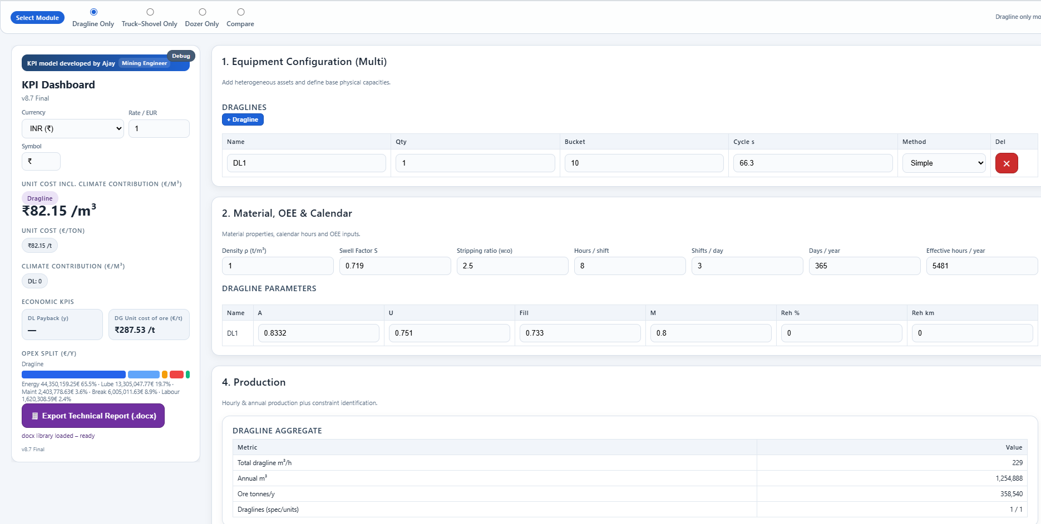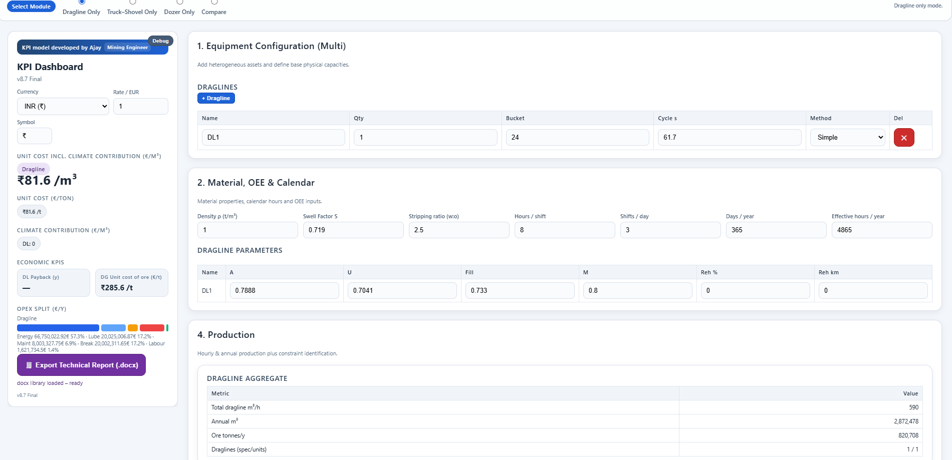

Tool output match the calculation with real mine data (NCL )

Also matched with various released academic data and research paper

Clarification on Scope

The developed tool also includes modules for Truck–Shovel systems and comparative benchmarking against draglines. However, the analytical scope of this thesis is strictly limited to dragline feasibility and TCO analysis. Truck–shovel modules and comparison results are presented within the tool for completeness, but they are not included in the detailed analysis or conclusions of this thesis

Maintenance and Case Study

Maintenance of Dragline

Dragline maintenance represents a critical determinant of both availability (A) and utilization (U), the two most important levers in dragline productivity and Total Cost of Ownership (TCO). Because draglines are highly capital-intensive machines with lifespans of 20–30 years, the choice of maintenance philosophy, inspection methods, and monitoring systems directly impacts lifecycle cost, safety, and production continuity.

Maintenance Philosophies and Frame work

1. Risk-Based Maintenance (RBM):
- Condition-Based Maintenance (CBM): Guided by inspections, sensors, and LiDAT monitoring. Applied to ropes, bearings, and control systems.
- Usage-Based Maintenance (UBM): Replacements at fixed hours, e.g., gear case bearings at 30,000 h.
- Design Improvement Maintenance (DIM): Engineering upgrades or reinforcements during major shutdowns.
- Run-to-Failure (RTF): Allowed for low-criticality items (e.g., dump ropes, minor GET components).
2. Non-Risk-Based Maintenance:
- Urgent (Corrective / Breakdown): Immediate intervention after failure.
- Deferrable (Time-Based Preventive): Periodic inspections, greasing, lubrication at fixed schedules.

Source-Dragline Maintenance Engineering A dissertation submitted by Bruce Thomas Jones

Maintenance activities may be broadly divided into planned and unplanned interventions.
Planned Maintenance
- Preventive (Scheduled Care): Calendar-based or usage-based maintenance tasks designed to prevent failure before it occurs. Examples include scheduled bearing changes and rope lubrication. This approach is aligned with Usage-Based Maintenance (UBM).
- Predictive (Condition-Based): Employs monitoring and diagnostic technologies such as LiDAT sensors, vibration trending, and oil ferrography to anticipate failures. This strategy aligns with Condition-Based Maintenance (CBM).
- Shutdown (Major Overhaul): Encompasses large-scale interventions and design improvements (DIM) carried out during scheduled outages. These are often timed with major inspections or seasonal shutdowns (e.g., monsoon-related downtime).
Unplanned Maintenance
- Corrective (Breakdown Repair): Emergency interventions following unexpected failures. These events are typically high-cost, high-impact occurrences, such as boom cracks or hoist rope failures.
Planned maintenance strategies enhance predictability and contribute to long-term availability, while unplanned maintenance depresses utilisation and inflates operating cost due to lost production and high corrective expenditure.

Liebherr Availability Framework

Calendar Time (CT)
This is the total calendar year (365 days × 24 h = 8,760 h). It represents the absolute maximum possible time the machine could theoretically operate.
Scheduled vs Unscheduled Time
- Scheduled Time (ST): The portion of CT during which the dragline is expected to be operational. Public holidays, major shutdowns (e.g., monsoon layoff), or long-term outages are excluded.
- Unscheduled Time (UT): Time lost due to external constraints (mine stoppage orders, strikes, environmental restrictions). Not attributed to the machine.

Calendar Time (CT)
Scheduled Time (ST) |  |  |  |  |  |  |  | Unscheduled Time (UT)
Available Time (AT) |  | Down Time (DT)
Operating Time (OT) | Operating Delay Time (OD) | Scheduled Down Time (SDT) |  |  | Unscheduled Down Time (UDT)
 |  | Preventive Maintenance (PM) |  | Other Active Down Time (OSDT) | Corrective Maintenance (CM) |  | Other Unscheduled Down Time (OUDT)
 |  | Active PM (APM) | Preparation or Delay (DPM) |  | Active CM (ACM) | Preparation or Delay (DCM)
Liebherr Avaliability

Available Time (AT) and Downtime (DT)
- Available Time (AT): The fraction of ST where the dragline is technically available for work. This excludes downtime due to maintenance or breakdowns.
- Downtime (DT): Any time lost due to machine unavailability (maintenance, repair, breakdowns).

Operating Time (OT) and Operating Delays (OD)
- Operating Time (OT): Actual productive hours when the dragline is digging, swinging, dumping, or casting.
- Operating Delay (OD): Time lost due to short interruptions such as waiting for blasted muck, dozer assistance, power dips, or operator delays.

Breakdown of Downtime Categories
- Scheduled Downtime (SDT): Planned activities, primarily Preventive Maintenance (PM) and scheduled shutdowns.
  - Active PM (APM): The time spent actually performing preventive maintenance tasks.
  - Delay PM (DPM): Preparation and logistical delays for PM (waiting for spares, crew, tools).
  - Other Scheduled Downtime (OSDT): Planned but non-maintenance stoppages, e.g., training, safety audits.

- Unscheduled Downtime (UDT): Unplanned stoppages such as breakdowns.
  - Corrective Maintenance (CM): Repairs following a component/system failure.
  - Active CM (ACM): Actual repair work (e.g., welding a boom crack).
  - Delay CM (DCM): Waiting time associated with breakdown repairs (e.g., spare not available, crane delayed).
  - Other UDT (OUDT): Non-maintenance unscheduled stops (e.g., emergency evacuation, accident investigation).

KPI Formulas

Mining companies track the following KPIs based on the above categories:
- Availability Ratio = AT / ST
% of scheduled time where dragline is ready to operate.
- Productive Availability = OT / ST
% of scheduled time spent in actual digging/casting.
- Overall Availability (OA) = AT / ST
Same as above but highlights machine readiness.
- Technical Availability (TA) = AT / (AT + ACM)
Refines availability by considering corrective maintenance events.
- Mean Time To Failure (MTTF) = AT / F
Average operating time between successive failures (F = number of failures).
- Mean Time To Repair (MTTR) = CM / F
Average time spent per corrective repair.
- Mean Time Between Failures (MTBF) = MTTF + MTTR
Classic reliability measure.
- Event Availability = MTTF / (MTTF + MTTR)
Fraction of time machine is up vs down across cycles.
- Mean Time To Maintenance (MTTM) = AT / (F + Npm)
Average interval between any maintenance (corrective + preventive).
- Mean Maintenance Time (MMT) = (APM + ACM) / (F + Npm)
Average duration of a maintenance event.
- Availability at Event Level (AA_event) = MTTM / (MTTM + MMT)
or equivalently, AT/(AT+APM+ACM)AT / (AT + APM + ACM)AT/(AT+APM+ACM).

Maintenance part and Life time

 | Component | Qty | COMPONENT LIFE TIME (REAL RUNNING HOURS) | % USE IN DRAGLINE | RELATIVE COMPONENT LIFETIME DRAGLINE APPLICATION
A | Electrical parts
1 | Cable Loom W2 left | 1 | 30000 | 100 | 30000
2 | Cable loom W2 right | 1 | 30000 | 100 | 30000
3 | Battery | 4 | 15000 | 100 | 15000
4 | Can Module 33 | 1 | 25000 | 100 | 25000
5 | Can Module 45 | 1 | 25000 | 100 | 25000
6 | Can Module 46 | 1 | 25000 | 100 | 25000
7 | Can Module 09 | 1 | 25000 | 100 | 25000
8 | Can module 21 | 1 | 25000 | 100 | 25000
9 | Can module 22 | 1 | 25000 | 100 | 25000
10 | Can module 24 | 1 | 25000 | 100 | 25000
11 | Can module 34 | 1 | 25000 | 100 | 25000
12 | Master switch right cross | 1 | 15000 | 100 | 15000
13 | Master switch left cross | 1 | 15000 | 100 | 15000
14 | Keyboard control stand left | 1 | 25000 | 100 | 25000
15 | Keyboard X23 | 1 | 25000 | 100 | 25000
16 | Control System | 1 | 25000 | 100 | 25000
17 | Monitor LCD | 1 | 15000 | 100 | 15000
18 | Control modem | 1 | 20000 | 60 | 33333,33333
19 | Angle transmitter | 1 | 20000 | 100 | 20000
20 | Proximity switch | 2 | 10000 | 77 | 12987,01299
21 | Gear cam limit switch | 2 | 15000 | 77 | 19480,51948
22 | Slewing angle transmitter | 1 | 15000 | 82 | 18292,68293
23 | force measuring strap | 2 | 15000 | 100 | 15000
B | Rope pulleys
24 | Rope pulley | 23 | 8000 | 10 | 80000
25 | Rope pulley | 1 | 8000 | 77 | 10389,61039
26 | Rope guard | 2 | 50000 | 77 | 64935,06494
27 | Sheaves Main boom head 1 | 1 | 8000 | 77 | 10389,61039
C | Electric motor drive
28 | Motor IP55 | 2 | 30000 | 100 | 30000
29 | ANBAUTEILE E-MOTOR | 2 | 30000 | 100 | 30000
30 | Distribution Gearbox | 1 | 15000 | 100 | 15000
31 | SLIP RING TRANSMITTER | 1 | 20000 | 100 | 20000
D | Diesel engine
32 | Engine | 1 | 15000 | 100 | 15000
33 | clutch | 1 | 15000 | 100 | 15000
34 | Diesel high pressure pump | 2 | 7500 | 100 | 7500
35 | Distribution Gearbox | 1 | 15000 | 100 | 15000
36 | Diesel Injector | 12 | 7500 | 100 | 7500
37 | Turbo | 2 | 15000 | 100 | 15000
38 | Starter | 2 | 7500 | 100 | 7500
39 | Generator | 1 | 7500 | 100 | 7500
40 | Heat exchanger | 1 | 15000 | 100 | 15000
E | Add blue system
41 | Add blue tank sensor | 2 | 8000 | 100 | 8000
42 | Nox sensor | 2 | 8000 | 100 | 8000
43 | ADD blue pumpe | 2 | 8000 | 100 | 8000
44 | Injector Add blue | 2 | 8000 | 100 | 8000
45 | SCR Module | 2 | 8000 | 100 | 8000
F | Crawlers
46 | Tension jack | 2 | 5000 | 10 | 50000
47 | Sprocket/tumbler | 2 | 5000 | 10 | 50000
48 | carrying roller | 2 | 9900 | 10 | 100000
49 | running roller | 13 | 5000 | 10 | 50000
50 | traction drive | 1 | 9900 | 10 | 100000
51 | Floor Plate | 2 | 8000 | 10 | 80000
52 | wear plates | 2 | 1000 | 10 | 10000
G | General hydraulic components
53 | Cooler Motor | 2 | 15000 | 100 | 15000
54 | Variable Displacement Motor | 2 | 15000 | 100 | 15000
55 | Block element | 1 | 15000 | 60 | 25000
56 | 2-3 valves | 2 | 15000 | 60 | 25000
57 | Foot pedal | 2 | 5000 | 10 | 50000
58 | Traveling motor | 2 | 15000 | 30 | 50000
59 | Rotary connection | 1 | 15000 | 82 | 15000
60 | LUDV Pump | 2 | 15000 | 60 | 25000
61 | Cooler Pump | 1 | 15000 | 100 | 15000
62 | Control pressure pump | 1 | 15000 | 100 | 15000
63 | Controll pressure_transformator | 1 | 15000 | 100 | 15000
64 | Flushing pump | 1 | 15000 | 100 | 15000
65 | Freefall pump | 1 | 15000 | 50 | 30000
66 | Heat exchanger | 1 | 20000 | 100 | 20000
H | Slewing gear
67 | Swing Motor | 4 | 15000 | 82 | 18292,68293
68 | Swing gear drive | 4 | 20000 | 82 | 25000
69 | Slewing Ring | 1 | 30000 | 82 | 35000
70 | Screws for Slewing Ring | 264 | 30000 | 82 | 35000
71 | Grease Pump | 1 | 25000 | 100 | 25000
72 | Pump | 1 | 12000 | 82 | 14634,14634
I | Air condition
73 | Air condition unit CPL. HVAC | 1 | 20000 | 100 | 20000
74 | Hoist winches
J | Winch cpl. | 2 | 20000 | 77 | 25000
75 | Overhaul Kit - Level 3 | 2 | 20000 | 77 | 25000
76 | Half shall Standard | 2 | 20000 | 77 | 25974,02597
77 | V. Motor DMVA.G. 165-165 | 4 | 15000 | 77 | 19480,51948
78 | V. Motor DPM O 165-165 | 2 | 15000 | 77 | 19480,51948
79 | Pump | 2 | 12000 | 77 | 15584,41558
K | Luffing
80 | V. Motor A6VM 170 | 1 | 15000 | 10 | 150000
81 | Fairlead
82 | Rope Pully Complete | 2 | 8000 | 77 | 10389,61039
83 | Guidung Roller | 2 | 8000 | 77 | 10000
84 | Roller Bearing | 4 | 12000 | 77 | 15000
85 | Roller Bearing | 1 | 12000 | 77 | 15000
86 | Roller Bearing | 1 | 12000 | 77 | 15000
87 | Cylinder | 2 | 8000 | 77 | 10000
88 | Valve Block | 1 | 15000 | 77 | 20000
L | Hydraulic hoses
89 | Fuel Tank | 1 | 15000 | 100 | 15000
90 | Fuel pump | 1 | 15000 | 100 | 15000
91 | Fuel system | 1 | 15000 | 100 | 15000
92 | Swing drive | 1 | 15000 | 100 | 15000
93 | Central power unit | 1 | 15000 | 100 | 15000
94 | Luffing gear | 1 | 15000 | 100 | 15000
95 | Winch 1 gear | 1 | 15000 | 100 | 15000
96 | Winch 1 ff | 1 | 15000 | 100 | 15000
97 | Winch 2 gear | 1 | 15000 | 100 | 15000
98 | Winch 2 ff | 1 | 15000 | 100 | 15000
99 | Uncercarriage | 1 | 15000 | 100 | 15000
100 | Crawler left + right | 1 | 15000 | 100 | 15000
101 | boom foot | 1 | 15000 | 100 | 15000
102 | reeving winch | 1 | 15000 | 100 | 15000
103 | Pactronic | 1 | 15000 | 100 | 15000
104 | Mooring control winch 1 | 1 | 15000 | 100 | 15000
105 | Mooring control winch 2 | 1 | 15000 | 100 | 15000
106 | Fairlead | 1 | 15000 | 100 | 15000
107 | boom foot bolts | 1 | 15000 | 100 | 15000
108 | hydraulic oil bypass filters | 1 | 15000 | 100 | 15000
109 | hydr. Access ladder | 1 | 15000 | 100 | 15000
110 | Maintenance flap | 1 | 15000 | 100 | 15000
111 | Heating superstructure | 1 | 15000 | 100 | 15000
112 | Diesel pump | 1 | 15000 | 100 | 15000
113 | central lubrication | 1 | 15000 | 100 | 15000
114 | Fairlead | 1 | 15000 | 100 | 15000
115 | Ad blue | 1 | 15000 | 100 | 15000
116 | boom back support | 1 | 15000 | 100 | 15000
117 | superstructure | 1 | 15000 | 100 | 15000
118 | gear oil cooling winch 1 | 1 | 15000 | 100 | 15000
119 | gear oil cooling winch 2 | 1 | 15000 | 100 | 15000
M | Ropes
120 | HOISTING ROPE 46mm | 1 | 700 | 77 | 909,0909091
121 | GRAB ROPE 46 mm | 1 | 600 | 77 | 779,2207792
122 | Luffing Rope | 1 | 1600 | 8 | 20000
N | Pactronic
123 | Pump Pac_DPV.G.280 | 1 | 15000 | 100 | 15000
124 | Pump feed pressure_Pac | 1 | 15000 | 100 | 15000
125 | Power unit_feedp._PAC | 1 | 15000 | 100 | 15000
126 | Piston_sealing set | 1 | 25000 | 100 | 25000

Case study

This chapter defines the scenarios, inputs, and methods used to evaluate annual production potential for dragline-based and comparator systems across four Indian surface-mining contexts: coal, rock phosphate, limestone, and (contextual reference) bauxite/gypsum. It explains (i) what data are required, (ii) how those data were collected and cleaned, and (iii) how they are transformed into production-per-year estimates using defensible, literature-based factors (bench geometry, swell/“soil” factor, bucket fill factor, availability/utilization, travel/positioning, and swing/hoist geometry).

Core data
Core variables for production modelling are derived from the standard cycle-time framework:
Q_hr = Cb × Ff × SF × (3600 / C) × M × A × U
Q_yr = Q_hr × (Ns × Nh × Nd)
where Cb = bucket capacity, Ff = fill factor, SF = swell factor, C = cycle time, M = travel/positioning factor, A = availability, U = utilization.

Site and material descriptors

- Geometry: bench height/width, highwall & bench slopes, typical digging depth, angle of repose, haul-road gradient. (Template table already collated in your notes.)

- Material properties: UCS ranges for OB and ore/soft-rock units to judge diggability or blasting need. (Table provided below.)

- Operations calendar & OEE: 330 working days/year; 3 shifts/day; 8 h/shift; CMPDI/CIL baselines A = 0.85, U = 0.73; positioning/travel M = 0.8

Site and material descriptors

- Dragline operating dimensions and cycle decomposition, swing-angle bands and theoretical cycle times by bucket class.

- Bench/dump geometry for balancing-diagram set-up (to minimize re-handling).

How the data were collected (provenance & workflow)
Mine-level geometry and operational data were compiled from Environmental Clearance (EC), Pre-Feasibility Reports (PFR), CMPDI norms, and literature. Each parameter (bench height, slope, UCS, etc.) was verified using government and OEM data

Coal

Bench height 28–41 m; width 50–60 m; highwall slope 70°, bench slope 60°, angle of repose ~38°.Walking draglines dominate OB removal; swing angle 120–150°, cycle ~60–70 s. Fill factor 0.85–0.95; swell 1.25–1.35.

Rock Phosphate

Principal mines: Jhamarkotra, Maton (Rajasthan). Bench height 10 m, width up to 40 m, slopes 70–80°, overall pit 36–45°. UCS 30–40 MPa (soft-medium). Suitable for HS 8300.2 crawler dragline; hybrid mode for 40–60 MPa zones.

Limestone

Mines: Dhanora, Jayantipuram, etc. Bench height 8–10 m, width 20–25 m, slope 70–80°. UCS 25–100 MPa; soft bands excavatable. Fill factor 0.8–0.9; swell 1.2–1.35. Low stripping ratios favor dragline deployment in soft zones.

Bauxite
Soft rock with UCS <5-27 MPa; 5–10 m benches, direct mechanical excavation feasible. Fill factor 0.9–0.95; swell 1.1–1.25.

Operational parameters (shift, staffing, maintenance)
Standard calendar: 330 days/year, 3 shifts/day, 8 h/shift. CMPDI norms: Availability 85%, Utilization 73%, Positioning factor 0.8.

Data table

Compressive Strength of Common Rocks- Mostly overburden
Rock Type | Typical UCS Range (MPa)
Granite (coarse) | 70–200 MPa
Basalt / Diabase | 100–250 MPa
Quartzite | 150–300 MPa
Sandstone | 15–120 MPa
Shale | 5–70 MPa
Limestone | 20–175 MPa
Marble | 50–150 MPa
Siltstone / Claystone | 5–40 MPa
Breccia / Conglomerate | 25–120 MPa

Block | Variable | Coal | Rock Phosphate | Limestone | Bauxite
Calendar | Nd, Ns, Nh | 330, 3, 8 | same | same | same
OEE | A, U | 0.85, 0.73 | same | same | same
Positioning | M | 0.8 | 0.8 | 0.8 | 0.8
Geometry | Bench Height (m) | 28–41 | 10 | 8–10 | 5–10
Material Including OB | UCS (MPa)  Classiication | 20–170  CAT II-V | 30–70  CAT II-V | 25–100  CAT II-V | <5-27  CAT I-II
Fill Factors | Ff | 0.85–0.95 | 0.85–0.95 | 0.8–0.9 | 0.9–0.95
Swell | Blasting | 1.35 | 1.5 | 1.55 | 1.35
Swell factor | 1/swell | 0.74 | 0.66 | 0.83 | 0.74
Method  Simple side casting  No Rehandling | SWING  ANGLE  AVG 90 | SWING  ANGLE  AVG 90 | SWING  ANGLE  AVG 90 | SWING  ANGLE  AVG 90 | SWING  ANGLE  AVG 90
(Primary Data and References listing NCL field data, CMPDI norms ,Govt of india data and other consideration)
Assumption – Efficient fragmentation based on rock properties and its suitable for dragline.

Test Inputs

Inputs for the test scenarios:
- Bucket capacity: 10.2 m³
- Positioning factor (M): 0.8
- Availability (A): 0.85
- Utilization (U): 0.73
- Shifts/day: 3, Hours/shift: 8, Days/year: 330
Life of machine -25 Years
Standard cycle time for dragline at 90 degree swing 60 sec

Material | Fill factor, Ff | Swell factor, SF | Cycle time (s)
Coal overburden OC (Cmpdi recommendation) | 0.9 | 0.74 | 60.0
Limestone (hard, well-fragmented) | 0.9 | 0.66
Bauxite (lateritic, friable) | 0.9 | 0.74
Rock phosphate (friable) | 0.9 | 0.83

Input data based on rock conditions

Production Result

Computed production by commodity
Considering Blasting is required
 | Nh | 8 | A | 0,73
 | Ns | 3 | U | 0,85
 | Nd | 330 | M | 0,8
 | TOTAL WORKING HOUR | 7920 | EFFECTIVE HOUR | 4914,36
Produktion Parameter | COAL | LIMESTONE | BAUXITE | ROCK PHOSPHATE
BC | 10,2 | 10,2 | 10,2 | 10,2
CT | 60 | 60 | 60 | 60
FF | 0,9 | 0,9 | 0,9 | 0,9
SF | 0,74 | 0,66 | 0,74 | 0,83
AxUxM | 0,4964 | 0,4964 | 0,4964 | 0,4964
Yearly production | 1602443,057 | 1429205,97 | 1602443,057 | 1797334,78
effective Hourly production | 326,0736 | 290,8224 | 326,0736 | 365,7312
Stripping ratio | 2,5 | 1 | 1,2 | 10
Overburden % | 0,714285714 | 0,5 | 0,545454545 | 0,909090909
ob in m3/ h | 232,9097143 | 145,4112 | 177,8583273 | 332,4829091
ore in m3/h | 93,16388571 | 145,4112 | 148,2152727 | 33,24829091
ob yearly | 1144602,183 | 714602,9848 | 874059,8492 | 1633940,709
ore yearly | 457840,8734 | 714602,9848 | 728383,2077 | 163394,0709

( SR is based on mining companies data by Minestry of mine and environment clearance report)

Total cost

Ownership cost per year-
PURCHASE PRICE ( including all charges ) | 7000000
Depreciation [years] | 25
CAPEX | 280000
IIT % | 15
YEARLY COO | 3640000
OWNERSHIP | 826000

IN INR 82600000 ( 1 EUR =100 INR)
(References listing NCL field data, CMPDI norms, Liebherr OEM sheet, and SME Handbook (2009))
Operatring cost -
 | Hourly | Yearly
LABOUR
OPERATOR (per year) |  | 6000
HELPER (per year ) |  | 5000
CONSUMPTION L/h | 70
euro/L | 0,95
fuel cost | 66,5 | 326804,94
LUBE % OF fuel | 8 | 26144,3952
MAINTAINANCE % OF fuel | 132 | 431382,5208
opex |  | 795331,856

IN INR 79533185 ( 1 EUR =100 INR)

Total cost 162133185 Yearly

Based on CMPDI 2023; SME 2009; Liebherr 2024)

Cost per m3

Parameter | Production Parameter | COAL | LIMESTONE | BAUXITE | ROCK PHOSPHATE
total (ob+ore | inr /m3 | 101,18 | 113,44 | 101,18 | 90,20
ore | inr /m3 | 354,12 | 226,88 | 222,59 | 992,28

TCO KEY PERFORMANCE INDICATOR

Environment contribution

Fuel-based (activity data).
For the HS 8300, a measured/assumed fuel burn of 70 L·h⁻¹ and a working calendar of 3×8×330 = 7,920 h·y⁻¹ are considered. Applying availability and utilization (A = 0.85, U = 0.73) yields productive engine hours
H_OT = 7,920 × 0.85 × 0.73 = 4,914 h·y⁻¹.
Annual fuel use and CO₂ (diesel emission factor 2.68 kg CO₂·L⁻¹):
F_y = 70 × 4,914 = 343,980 L·y⁻¹,
CO₂_HS = 343,980 × 2.68 = 922 t CO₂·y⁻¹.
For an annual handled volume Q_y, the fuel-based intensity is I_HS,fuel = CO₂_HS / Q_y.
Example (coal case Q_y = 1.60 Mm³·y⁻¹): I_HS,fuel = 0.58 kg CO₂·m⁻³.
Benchmark comparison (intensity-based).
CO2 produced per liter = 2.6 kg CO₂·m⁻³.
Thus, at Q_y = 1.60 Mm³·y⁻¹, the HS 8300 avoids 2.6 × 1.60 = 4,160 t CO₂·y⁻¹
Implied carbon intensity per cubic metre
For each case study volume $Q_{y}$:
$$I_{\text{HS,fuel}}=\frac{{\text{CO}\text{₂}}_{\text{HS}}}{Q_{y}} [kg /m^{3}]$$
Case (Qy, Mm³/y) | CO₂ (t/y, 2.68 kg/L) | $I_{\text{HS,fuel}}$(kg/m³)
Coal (1.60) | 922 | 0.58
Phosphate (1.80) | 922 | 0.51
Limestone (1.43) | 922 | 0.65
Bauxite (1.60) | 922 | 0.58

Based on file observations 1 litre diesel emits 2,68 kg co2
Note. These intensities are derived purely from the 70 L/h assumption. If the observed site fuel rate is higher, intensities scale linearly.

Result and conclusion

List of Figures

Figure 1: Montanromantik 2

List of Tables

Table 1: Table 2

List of Abbreviations
U. S. P. | Unique selling proposition

Annex Table of Contents

Annex

